Introduction and Background
Waste heat in manufacturing arises from various industrial systems dispersed throughout a facility. The primary contributors to waste heat in most industries include exhaust and flue gases, as well as heated air from systems like burners used in process heating. These can range from high-temperature gases in burners to lower-temperature emissions from heat-treating furnaces, dryers, and heaters. Heat is also lost from equipment like heat exchangers and through cooling liquids and gases.
While exhaust gases are the most obvious source, waste heat also exists in liquids and solids. Examples of liquid-based waste heat include cooling water, heated wash water, and blow-down water. Solid waste heat sources include hot products discharged after processing or chemical reactions, and hot by-products from processes or combustion of solid materials. Additionally, less noticeable sources of waste heat include hot surfaces, steam leaks, and boiler blow-down water.
Table 1 highlights common major sources of waste heat, detailing their temperature ranges and specific characteristics.
.

Table 1: Temperature Range and Characteristics for Industrial Waste Heat Sources

Waste Heat Source | Temperature Range °F | Temperature Range °C | Cleanliness
Furnace or heating system  exhaust gases | 600 – 2,000 | 316 – 1,100 | Varies
Gas (combustion) turbine  exhaust gases | 900 – 1,100 | 480 – 600 | Clean
Reciprocating engines
Jacket cooling water | 190 – 200 | 90 – 100 | Clean
Exhaust gases (for gas fuels) | 900 – 1,100 | 480 – 600 | Mostly clean
Hot surfaces | 150 – 600 | 65 – 316 | Clean
Compressor after or inter cooler  water | 100 – 180 | 38 – 82 | Clean
Hot products | 200 – 2,500 | 100 – 1,370 | Mostly clean
Steam vents or leaks | 250 – 600 | 120 – 316 | Mostly clean
Condensate | 150 – 500 | 65 – 260 | Clean
Emission control devices –  thermal oxidizers, etc. | 150 – 1,500 | 65 – 816 | Mostly clean

Previous Studies
Several reports commissioned by the Department of Energy (DOE) and other organizations have examined waste heat sources, focusing primarily on industrial heating systems. The scope of these studies ranged from estimating annual energy losses in British Thermal Units (Btus) across various heating systems to analyzing waste heat sources across industries and identifying broad opportunities for research and development. Below is a summary of key waste heat studies referenced in this analysis.
Energy Use and Loss Analysis
The Energy Use and Loss Analysis report, prepared by Energetics Incorporated, provides an overview of energy consumption across major manufacturing sectors defined by the North American Industry Classification System (NAICS) codes. The analysis relies on data from the Manufacturing Energy Consumption Survey (MECS), published by the Energy Information Agency, to identify key areas of energy use within industrial plants and estimate losses within their subsystems, as illustrated in Exhibit 2.
Loss estimates were calculated using percentage loss factors for major energy-use areas, as detailed in Exhibit 3. By applying these factors to the energy consumption data, the report generated estimates of energy losses across various industrial sectors, as presented in Exhibit 4. However, the study did not focus on pinpointing specific waste heat sources within energy systems.

Figure 1: Major Areas of Energy Use in a Manufacturing Plant
Fossil
Energy Supply

Inside Plant Boundary
Facilities/HVAC/ Lighting

Solar/Geo-
_{thermal/Wind} Energy Recycle
Energy
Process Energy Systems

Central Energy Energy Process Energy Distribution Conversion Energy
Generation/ Use
Utilities

Energy Energy
Losses Losses TBD
Industrial Plant Boundary
Energy
Supply
Utility/
Power Plant
Energy Export
Fossil
Energy Supply
Energy Recycle
Process Energy Systems
Central
Energy Generation/ Utilities
Process
Energy Use
Utility/
Power Energy
Plant Losses
Energy
Losses
TBD
Industrial Plant Boundary
Energy Supply
Solar/Geo- thermal/Wind Energy
Energy Conversion
Energy Distribution
Facilities/HVAC/ Lighting
Plant Operation/System Process Energy System

Source: Energy Use, Loss and Opportunities Analysis: U.S. Manufacturing and Mining, Energetics Incorporated and E3M, 2004.

Table 2: Energy Loss Factors for Major Energy Systems in a Manufacturing Plant

Energy System | Percent Energy Lost
Steam systems | Boilers – 20%  Steam pipes and traps - 20%  Steam delivery/heat exchangers – 15%
Power generation | Combined heat and power – 24% (4500 Btu/kWh) Conventional power – 45% (6200 Btu/kWh)
Energy distribution | Fuel and electricity distribution lines and pipes (not steam) – 3%
Energy conversion | Process heaters – 15% Cooling systems – 10%  Onsite transport systems – 50% Electrolytic cells – 15%  Other – 10%
Motor systems | Pumps – 40%  Fans – 40% Compressed air – 80% Refrigeration – 5% Materials handling – 5%  Materials processing – 90% Motor windings – 5%

Source: Energy Use, Loss and Opportunities Analysis: U.S. Manufacturing and Mining, Energetics Incorporated and E3M, 2004.

Figure 2: Estimates of Energy Losses for Major Energy Use Areas in Manufacturing





Other
To Processes
Generation Losses
Distribution Losses Conversion Losses
To Processes
Generation Losses
Distribution Losses Conversion Losses
683
TBtu

362
TBtu
2336
TBtu
7279
TBtu
Potential Process Losses
6201 TBtu
1405
TBtu
To Processes Generation Losses Distribution Losses Conversion Losses

Electrochemical

Motor Systems

Fired Heaters & Cooling
Potential Process Losses

Steam Systems

Facilities

0 1000 2000 3000 4000 5000 6000 7000
Trillion Btu
*Onsite generated power has been distributed among end-uses and is not included in the total.

Source: Energy Use, Loss and Opportunities Analysis: U.S. Manufacturing and Mining, Energetics Incorporated and E3M, 2004.

Waste Heat Recovery: Technology and Opportunities in U.S. Industry
The Industrial Technologies Program (ITP) published an in-depth report by BCS Incorporated, titled Waste Heat Recovery: Technology and Opportunities in U.S. Industry. This report offers comprehensive insights into waste heat sources across major industrial sectors, the characteristics of waste heat, the currently available recovery technologies, and the research, development, and demonstration (RD&D) needs. It classifies waste heat sources into three temperature categories:
- High temperature: >1,200°F (650°C)
- Medium temperature: 450°–1,200°F (230°–650°C)
- Low temperature: <450°F (230°C)
The report includes a waste heat profile that describes the types of waste heat discharged from industrial facilities, general observations on waste heat sources, and existing waste heat recovery practices. It highlights RD&D opportunities to broaden the economic viability of conventional technologies and explore emerging and innovative solutions.
One significant finding of the report is the estimation of waste heat quantities based on different reference temperatures. At a baseline of 77°F (25°C), industrial plants discharge approximately 1,478 trillion Btu of waste heat annually. However, when the reference temperature is increased to 300°F (150°C), this figure drops to 256 trillion Btu per year. This reveals substantial heat recovery potential within the 77°–300°F (25°–150°C) range, which accounts for over 80% of total waste heat. The findings underscore the critical need for R&D initiatives to address this temperature range.
Exhibit 5 provides a summary of key RD&D opportunities identified in the BCS report, aligned with the barriers they aim to overcome.

Table 3: RD&D Opportunities and Barriers Addressed

 | Barriers Addressed
 | Long Payback Periods | Material Constraints and Costs | Maintenance Costs | Economies of Scale | Lack of End-Use | Heat Transfer Rates | Environmental Concerns | Process Control and Product Quality | Process-Specific Constraints | Inaccessibility
Develop low-cost, novel materials for resistance to corrosive contaminants and  to high temperatures |  | x | x
Economically scale down heat recovery equipment | x | x |  | x
Develop economic recovery systems that can be easily cleaned after exposure to  gases with high chemical activity |  |  | x | x |  | x
Develop novel manufacturing processes that avoid introducing contaminants into  off-gases in energy-intensive manufacturing processes |  | x | x |  |  |  | x | x | x
Develop low-cost dry gas cleaning  systems |  | x | x |  |  | x | x | x
Develop and demonstrate low- temperature heat recovery technologies, including heat pumps and low-  temperature electricity generation |  | x |  |  | x
Develop alternative end-uses  for waste heat |  |  |  |  | x
Develop novel heat exchanger designs  with increased heat transfer coefficients | x | x |  |  |  | x
Develop process-specific heat recovery  technologies |  |  |  | x |  | x | x | x | x | x
Reduce the technical challenges and  costs of process-specific feed preheating systems | x |  |  | x |  | x |  | x | x
Evaluate and develop opportunities for  recovery from unconventional waste heat sources (e.g., sidewall losses) |  |  |  |  |  |  |  |  | x | x
Promote new heat recovery technologies  such as solid-state generation |  |  |  |  |  |  |  |  |  | x
Promote low-cost manufacturing techniques for the technologies  described above | x | x | x | x | x | x | x | x | x | x

Source: Waste Heat Recovery: Technology and Opportunities in U.S. Industry, BCS, 2008.

Opportunity Analysis for Recovering Energy from Industrial Waste Heat and Emissions
The Pacific Northwest National Laboratory (PNNL) report, Opportunity Analysis for Recovering Energy from Industrial Waste Heat and Emissions, explores the availability of waste energy in industrial processes. It examines the barriers and potential pathways for recovering chemical and thermal emissions from U.S. industries, aiming to maximize the utilization of these untapped energy resources.
A key focus of the study was quantifying the volume and energy value of these emissions. Using publicly available literature, the authors assessed the energy embedded within industrial emissions and identified technological opportunities for capturing and reusing it. The report highlights that U.S. industries possess approximately 2,180 petajoules (PJ), or 2 Quads (quadrillion Btu), of residual chemical fuel value. Excluding emissions from non-industrial sources like landfills, the industrial component alone accounts for 1,480 PJ (1.4 Quads), representing roughly 4.3% of the total energy consumption of U.S. industries.
The report also evaluates advanced materials and technologies with significant potential for recovering and re-utilizing emissions. Promising solutions include materials like thermoelectric, thermionic, and piezoelectric systems, as well as technologies such as solid oxide fuel cells. To make these solutions more cost-effective and commercially viable, the authors emphasize the need for further research, development, and industry education.

Engineering Scoping Study of Thermoelectric Generator (TEG) Systems for Industrial Waste Heat Recovery
In November 2006, PNNL and BCS, Incorporated released the report Engineering Scoping Study of Thermoelectric Generator (TEG) Systems for Industrial Waste Heat Recovery. The study evaluated the feasibility of using TEG systems to recover industrial waste heat, focusing on the following objectives:
- Identifying and quantifying waste heat sources suitable for TEG applications in industrial processes.
- Defining the operating conditions TEG systems would encounter and estimating their performance in selected processes.
- Assessing cost, design, and engineering performance requirements for successful TEG integration.
- Highlighting research, development, and deployment (RD&D) needs to address challenges limiting TEG adoption.
The study selected three high-temperature industrial processes to explore TEG applicability:
- Glass furnaces: 905°–2,550°F (485°–1,400°C)
- Aluminum Hall-Héroult cells: ~1,760°F (~960°C)
- Reverberatory furnaces: ~1,400°F (~760°C)
The analysis concluded that deploying TEGs in glass furnaces alone could generate over $25 million in annual sales, assuming high-efficiency TEGs with a dimensionless figure of merit ZT∼2ZT \sim 2 are produced at $5 per watt and achieve a 5% annual market penetration.
The report recommends further RD&D in thermal transfer technologies and engineering solutions to integrate TEG systems with existing industrial equipment. This includes studies on modifying exhaust systems, such as altering duct lengths and residence times, to improve compatibility with TEG systems.

Waste Heat Temperature Ranges
Recognizing the critical role of temperature in waste heat recovery, the study expanded the conventional classification of temperature ranges to include:
- Ultra low temperature (<250°F or <120°C): Includes ambient cooling water or flue gases with condensation temperatures below ~180°F (~82°C).
- Low temperature (250°–450°F or 120°–230°C): As defined in the BCS report.
- Medium temperature (450°–1,200°F or 230°–650°C): As defined in the BCS report.
- High temperature (1,200°–1,600°F or 650°–870°C): Refined based on equipment and material availability.
- Ultra high temperature (>1,600°F or >870°C): Requires specialized materials like ceramics due to the presence of contaminants and high thermal stresses.
This expanded classification enables exploration of RD&D opportunities in both ultra-low and ultra-high temperature ranges, where cost-effective recovery methods and equipment are particularly challenging to implement.

Other Reports
The Lawrence Berkeley National Laboratory (LBNL) Industrial Energy Study group has published multiple reports on energy use and efficiency improvement opportunities. For example, Energy Efficiency Improvement and Cost Savings Opportunities for Petroleum Refineries: An ENERGY STAR Guide for Energy and Plant Managers outlines strategies for energy efficiency across industries such as steel, cement, and food processing. These reports also address waste heat recovery and recommend technologies to reuse waste energy in industrial processes.
A July 2009 report by McKinsey & Company, Unlocking Energy Efficiency in the U.S. Economy, explores the potential for improving non-transportation energy efficiency and identifies barriers to achieving this goal. The report advocates recognizing energy efficiency as a critical energy resource and fostering innovation in next-generation energy efficiency technologies. However, it does not specify R&D program areas.
In September 2009, an industry-government forum on Energy-Intensive Processes took place at the ITP-sponsored Energy-Intensive Processes Workshop. This event aimed to review ITP’s R&D portfolio and gather recommendations for future efforts. A session focused on waste heat minimization and recovery highlighted strategies to reduce the fuel demands of steam boilers and furnaces by utilizing waste heat recovery. Workshop participants identified the following key areas of interest for R&D:
- Ultra-High Efficiency Steam Generation: Projects like the "super boiler."
- High-Efficiency Process Heating Equipment:
  - Ultra-high efficiency combustion.
  - Advanced insulation and refractory systems.
- Waste Energy Recovery:
  - Low-temperature heat utilization.
  - Advanced energy conversion technologies (e.g., solid-state and mechanical).
  - Recovery from high-temperature, contaminated flue gases.
  - Demonstrating waste-heat-to-electricity technologies in industrial settings.
- Waste Energy Minimization:
  - Development of high-efficiency compressors, motors, and variable-speed drives.
  - Heat transfer improvements through advanced coatings and corrosion resistance.
- Process Intensification and Integration:
  - Integration of industrial control system components (e.g., valves, actuators, and sensors).
  - Transition from batch to continuous operations.
  - Predictive modeling and simulation for combustion processes.

Findings from Previous Reports
Analysis of earlier studies, along with input from industry professionals and equipment suppliers, indicates significant unrecovered waste heat in two key temperature ranges:
- Ultra-low (<250°F or <120°C): Challenges include the lack of economically viable equipment and techniques to recover low-grade heat effectively.
- Ultra-high (>1,600°F or >870°C): Recovery is hindered by technological and material limitations, as well as the presence of contaminants in high-temperature waste heat streams.
These findings highlight the need for targeted R&D to develop cost-effective solutions for heat recovery in these challenging temperature ranges.

Waste Heat in Major Industry Sectors
This study examines various industrial sectors to identify waste heat sources and their availability, explore potential applications for waste heat both within and outside the plant, review experiences with waste heat recovery, and evaluate barriers to implementation. The analyzed sectors include:
- Aluminum: Primary Production.
- Aluminum: Recycling and Secondary Melting.
- Steel: Integrated Steel Mills.
- Steel: Mini Mills or Electric Arc Furnace (EAF) Mills.
- Glass: Fiberglass Manufacturing.
- Chemicals and Petroleum Refining: Major Operations.
- Paper: Paper Mills.
- Food: Snack Manufacturing.
- Cement: Dry Process and Shaft Furnaces.
- Coatings: Vinyl Coating Mills.

Key Considerations in Each Sector
For each sector, the study assessed:
- Plant Operations and Waste Heat Sources: Processes and operations, sources of waste heat, and current practices for waste heat utilization or discharge.
- Energy Use and Potential Applications: Utilities and other energy-dependent operations where waste heat or its converted forms (e.g., electricity) could be applied.
- Waste Heat Management Activities: Strategies for reducing, recycling, and recovering waste heat.
- Implementation Criteria: Economic and operational requirements needed to justify and execute waste heat recovery projects.
- Sector-Specific Challenges: Factors that influence waste heat management practices within plants and across the industry.

Overview of Findings
For each sector, representative waste heat sources, their characteristics, and recovery efforts were analyzed. Additionally, the study explored potential uses for waste heat within a typical plant, offering a summary of sector-specific issues and opportunities related to waste heat recovery. These insights provide a foundation for understanding the challenges and possibilities for waste heat management in each industry.

Aluminum – Primary Production

Refining

Calciners
The calcination process accounts for a significant portion of the energy required in aluminum production, making waste heat from calciners a prime target for recovery. The exhaust from calciners contains:
- High moisture content: Approximately 50% water by volume.
- Contaminants: Alumina particulates.
- Low temperatures: Ranging between 365°–392°F (185°–200°C).
Recovering heat from this exhaust is challenging due to severe fouling of heat exchangers caused by particulates and low-temperature moisture. To address this, the industry is exploring:
- Latent heat recovery: Investigating technologies to capture the heat within the water vapor.
- Collaborative efforts: Partnering with organizations to identify innovative recovery solutions.

Hot Alumina Discharge
Another significant heat source is the high-temperature discharge of hot alumina. Despite the elevated temperature, the presence of particulates poses similar challenges. Current efforts include:
- Hot water production: Recovering heat to generate hot water for use in processes within the plant.
- Kalina cycle integration: Using excess heat to support the Kalina cycle for electricity production.
- Cogeneration facilities: Large plants may consider cogeneration systems to maximize heat utilization.

Coke Calciner Afterburner Waste Gas
An additional recovery opportunity lies in the high-temperature waste gas streams from coke calciners, which reach 1,900°–2,000°F (1,040°–1,090°C). This heat can be utilized to:
- Generate steam: For use in industrial processes.
- Produce electricity: Through waste heat recovery systems.
The implementation of these recovery strategies, particularly for the afterburner waste gas, hinges more on economic feasibility and business considerations than on research and development needs.

Smelting

Electrolysis – Pots
Electrolysis pots offer significant potential for heat recovery, with major heat losses occurring in the sidewalls and endwalls (15%–20%) and through off gases (approximately 15%). A notable heat flux band, about 500 mm high, surrounds the pot circumference, characterized by:
- Heat flux: 10–15 kW/m².
- Temperature range: 570°–1,020°F (300°–550°C), with a typical operating temperature of 842°F (450°C). Higher temperatures occur during intensified production.
Potential Recovery Technologies
- Thermoelectric Devices:
  - These devices could be attached to the steel shell covering the pot walls.
  - Accessibility is influenced by pot age and design; for instance, Warwick smelting pots are particularly challenging to access.
  - Trials in other countries have demonstrated proprietary results.
Crust (Ledge) Management
The pots operate with a thin crust (“ledge”) a few centimeters thick, maintained by a heat sink to ensure thermal balance. Excessive cooling thickens the crust, reducing pot capacity. Alcoa is exploring ways to recover heat while preserving the pot’s thermal equilibrium. Capturing and removing hot air generated by natural convection around the pots could stabilize operations and enhance the work environment.

Emerging Technologies
- Thermoelectric (TE) Devices:
  - As ZT values approach 1.5, opportunities for TE device applications will expand, with technology expected to improve over time.
  - Key R&D focus areas include:
    - Heat sink management and thermal balance.
    - Scaling and integration of TE modules into practical devices.
    - Infrastructure development, power quality management, and handling thermal expansion.
    - Cold-side heat recovery and system durability.

Off Gas Heat Recovery
- Temperature Profile:
  - Post-scrubbers: 212°F (100°C).
  - Pre-scrubbers: 212°–266°F (100°–130°C).
- Challenges:
  - Fouling and particulate build-up in ducts.
  - Open duct systems for maintenance.
  - Effective gas cleaning remains a significant obstacle.

Existing Solutions and Case Studies
- A European installation uses a gas-to-water heat exchanger upstream of scrubbers to recover heat from smelting exhaust.
  - Recovered heat is used for district heating systems (e.g., Iceland).
  - The system has been operational since mid-2010.

Additional Opportunities
- Organic Rankine Cycle (ORC):
  - Industry efforts focus on ORC improvements, with initial tolerance for payback periods of up to five years.
  - Long-term goals aim to reduce payback periods to 2–3 years by leveraging process benefits and avoiding downstream equipment investments.

Thermoelectric Efficiency (ZT)
- ZT Indicators:
  - A ZT of 1 is considered good, while values of 3–4 are needed for TE devices to rival mechanical systems in efficiency.
By integrating emerging technologies and addressing key challenges, the aluminum industry aims to enhance waste heat recovery efficiency and overall sustainability in smelting operations.

Anode Baking
The anode baking process generates significant heat loss through hot exhaust gases produced during fuel combustion. These gases often contain volatiles and tar vapors, leading to fouling challenges.
- Exhaust Characteristics:
  - Temperature: 390°–750°F (200°–400°C).
  - Composition: Includes excess air and tars.
- Technological Developments:
  - Cleaner Pitch Burn Technology shows promise for improved waste heat recovery.
- Research Opportunities:
  - Revisit studies from the 1970s and 1980s.
  - Collaborate with the Norwegian Research Council, Norwegian Technology University, and other European institutes to develop practical solutions for waste heat reduction and recovery.

Melting

Primary Cast Side
Holding furnaces on the primary side use a cold charge to cool superheated metal or boost production. These furnaces typically operate in semi-continuous or batch modes, creating variable exhaust gas flows and temperatures.
- Exhaust Characteristics:
  - Predominantly gas-fired; some electric furnaces exist.
  - Hydrogen fluoride levels range from <1 ppm to 5–10 ppm, restricting the use of conventional heat exchangers.
- Heat Loss Areas:
  - Wall losses and opening losses contribute significantly to heat input.
  - Best practices in furnace design and operation can reduce these losses.
- Impact: Heat losses are categorized as low-impact, high-complexity.

Secondary Side
Melting furnaces on the secondary side discharge substantial heat as high-temperature exhaust gases.
- Exhaust Characteristics:
  - Temperature: >1,600°F (870°C).
  - Contaminants: Particulates, organic vapors, and flux material vapors.
- Challenges and Opportunities:
  - Separating contaminants at high temperatures is a cross-industry need.
  - Treating gases with absorbents to neutralize pollutants before cooling offers potential.
  - Cleaner gases could enhance compatibility with existing heat recovery systems.
  - Pre-cleaning or pre-treating flue gases is identified as an R&D priority.

Emerging Technologies
- Submerged Combustion Devices: Enhance heat transfer efficiency.
- Direct Immersion Heaters: Interest exists, but material selection is critical due to molten aluminum's corrosive nature.
- Induction Heating: Although promising, limitations include efficiency and scalability for the required energy ranges.

Other Operations
Semi-fabrication processes consume a relatively small portion of the total energy in aluminum plants.
- Waste Heat Characteristics:
  - Discharged as clean exhaust gases.
  - Recovery can be achieved through established methods such as recuperators, regenerators, or regenerative burners.
- Best Practices:
  - Conventional heat recovery systems are highly effective and widely implemented in these operations.
Through targeted R&D and advancements in heat recovery technologies, significant energy efficiencies can be achieved across these aluminum production processes

Aluminum – Recycling and Secondary Melting
Secondary aluminum melting involves several key sources of waste heat, as outlined below:

1. Clean Exhaust Gases
- Sources: Reverb furnaces, gas generators, crucible heaters.
- Characteristics:
  - Temperature ranges:
    - 1,450°F (790°C) in crucible heaters.
    - 2,000°F (1,090°C) in reverb furnaces.
  - Composition: Combustion products of natural gas, free from major contaminants.
  - Energy Potential: Contains up to 60% of total heat input for heating systems.
- Recovery Opportunities:
  - Preheating combustion air via recuperators or regenerative units.
  - Employing low-temperature power-generating cycles, such as organic Rankine-cycle systems.
  - Limited use for hot water, air, or cooling systems.

2. Rotary Furnace Gases
- Characteristics:
  - Lower temperature.
  - High levels of contaminants.
  - Cyclic and unpredictable mass flow rates.
- Challenges:
  - No standardized method exists for sensible heat recovery.
- Potential Solutions:
  - Developing low-pressure drop filters.
  - Using advanced high-temperature fabric materials in baghouses to clean gases for recovery.

3. Delacquering Systems
- Process:
  - Preheat UBCs (used beverage cans) to ~900°F (480°C) in rotary kilns to remove volatile materials.
  - Preheated UBCs are then charged into the reverb furnace.
- Exhaust Characteristics:
  - Relatively clean exhaust gases, discharged at ~650°F (340°C).
  - Generated by incinerating paint volatiles from UBCs.
- Recovery Status: Currently, no heat recovery is performed.

4. Crucible Heaters
- Function: Preheat crucibles before pouring molten aluminum from rotary or reverb furnaces.
- Characteristics:
  - Discharge gases at ~1,450°F (790°C).
  - Small, uncontrolled burners.
- Recovery Status: Heat remains unrecovered.

Steel – Integrated Steel Mill
Waste heat in integrated steel plants arises from three key areas:

1. Blast Furnaces and Iron-Making Process
- Involves high-temperature operations and the potential for power generation onsite.

2. Coke Ovens and Gas Processing Equipment
- Waste heat opportunities exist during coke production and processing of coke oven gases.

3. Reheating and Heat Treating Furnaces
- Found in rolling and finishing areas, these furnaces discharge significant amounts of heat suitable for recovery.
Targeted innovations in waste heat management can unlock efficiency gains and environmental benefits across both aluminum recycling and integrated steel production sectors.

Blast Furnace, Iron Making, and Power Generation
This section covers waste heat sources and recovery opportunities in integrated steel plant processes, including blast furnaces, power plants, and steel-making operations using the Basic Oxygen Process (BOP) system.

Blast Furnaces (BF)
Blast furnaces use a hot air blast enriched with 5%–10% oxygen to enhance production, with preheated air temperatures ranging from 1,950°–2,050°F (1,066°–1,122°C). Natural gas and coal injections are common in some plants. The waste heat sources include:
- Hot Blast Furnace Gas (BFG)
  - Contains sensible heat but requires cleaning to remove particulates, sulfur, and other contaminants.
- Moisture Removal from BFG
  - BFG has a heating value of ~90 Btu/cu ft. Reducing moisture content improves combustion characteristics and raises flame temperature.
- Flared BFG Heat Recovery
  - Recovering or converting flared BFG into usable energy, such as electricity, can enhance energy efficiency.

Blast Furnace Stoves
BF stoves preheat the blast air using direct-fired regenerators fueled by BFG, coke oven gas (COG), and natural gas. Waste heat opportunities include:
- Dehumidifying BFG
  - Removing moisture prior to use enhances efficiency.
- Exhaust Gas Heat Recovery
  - Stove exhaust gases (~600°F or 316°C) are clean and suitable for heat recovery systems.
- Oxygen-Enriched Combustion
  - Adding oxygen to combustion air improves flame temperature and heat transfer while reducing gas volume. This method may also replace natural gas, depending on cost and onsite oxygen availability.

Power Plant (Boilers – Steam System)
Integrated steel plant boilers utilize BFG and COG as fuel. Boiler exhaust gases, varying from 650°–840°F (340°–450°C), are clean and require no conditioning. Opportunities for waste heat recovery include:
- Preheating Fuel Gases
  - Using exhaust gases to preheat BFG and COG.
- Low-Temperature Power Generation
  - Employing systems like organic Rankine cycles where economically viable.
- Water Preheating
  - Preheating service or river water for plant use, particularly in colder months.
- Steam Venting Recovery
  - Capturing and condensing low-pressure steam for reuse in the boiler water system.

Steel Making – Basic Oxygen Process (BOP) Area
The BOP system generates high-temperature exhaust gases (>2,000°F or 1,090°C) with particulates and other contaminants. Heat recovery is challenging due to variability and periodic flow, but opportunities include:
- Steam Production
  - Using heat for steam generation with large accumulators.
- CO₂ Capture
  - Extracting CO₂ for integration into the water system.

Caster Area
In the caster area, the de-gasser uses 250 psig steam, which is de-superheated before application. Waste heat sources include:
- De-Superheating Heat
  - Heat generated during the de-superheating process.
- Discharged Steam
  - Heat from contaminated steam and condensate discharged at the end of the de-superheating process.
These waste heat recovery opportunities can significantly improve energy efficiency, reduce emissions, and optimize overall operations within an integrated steel plant.

Coke Plant
Coke facilities typically consist of multiple coke oven batteries, along with extensive equipment for recovering by-products from the coke-making process. These plants utilize large boilers operating at pressures of 600 psig or higher, primarily fueled by Coke Oven Gas (COG) with natural gas as a supplementary fuel. The generated steam powers various plant processes, with approximately 10% being returned. An incinerator is often employed for final gas cleaning.

Key Waste Heat Sources in Coke Plants:
- Hot Coke from Batteries
  - Hot coke contains ~1 MMBtu/ton of heat lost during rapid quenching, making it the largest source of waste heat. Dry quench systems, proven in several facilities, can recover this heat for power generation.
- Hot Coke Oven Gas (COG)
  - Discharged at ~1,500°F (815°C), COG contains particulates, condensable liquids, and sulfur compounds. The gas is quenched and cooled, losing 0.3–0.4 MMBtu/ton of coke as waste heat, mostly through hot water from the cooling system.
- Exhaust Gases from Coke Oven Batteries
  - With regenerative heat recovery, these gases are discharged at 400°–600°F (200°–320°C). While relatively clean, recovery options like low-temperature power generation are currently uneconomical due to long payback times.
- Clean Boiler Flue Gases
  - These low-temperature gases may heat water via direct or indirect exchangers, though carbonic acid condensation could pose issues. Marginal economic benefits are expected.
- Energy from the Incinerator
  - Heat recovery using recuperators or regenerators is possible but may involve long payback periods.

Rolling Mill and Finishing Area
Processes in this area, such as reheat and annealing, utilize natural gas, COG, and BFG as fuel. Slabs are typically heated to 2,150°F (1,180°C) before processing. Older systems may have low air preheat temperatures (below 700°F or 370°C), with exhaust gas temperatures ranging between 1,000°–1,250°F (540°–680°C) and oxygen levels exceeding 8%.

Waste Heat Sources in Rolling Mills:
- Exhaust Gas from Furnaces
  - Clean but high in excess air. Improved recuperators and reduced oxygen levels could enhance heat recovery.
- Radiation Heat from Furnace Openings
  - Heat loss occurs at charge/discharge points, roofs, and furnace walls.
- Heat from Rolled Steel Shapes
  - Heat recovery from rolled shapes, though uncommon, offers potential energy savings.

Steel – Mini Mill or EAF Mill
Electric Arc Furnace (EAF) mills produce various waste heat streams, typically involving high-temperature gases.

Waste Heat Sources in EAF Mills:
- Clean Exhaust Gases
  - Reheat furnaces, tundish heaters, and ladle heaters emit gases ranging from 1,000°F (540°C) to 1,800°F (980°C). These gases, free of major contaminants, account for up to 35% of the heating system's total heat input.
  - Recovery options include:
    - High-efficiency heat recovery systems.
    - Load or charge preheating.
    - Steam and power generation.
    - Low-temperature power generation using organic Rankine cycles.
- Gases Discharged from EAF
  - Hot, contaminant-laden gases with unpredictable flow rates currently lack industry-accepted methods for heat recovery.
- Hot Surfaces and Heat from Walls
  - Ladle and tundish heaters lose heat through their walls, representing additional opportunities for recovery.
By implementing effective heat recovery strategies, these processes can significantly reduce energy waste and operational costs.

Glass – Fiberglass Manufacturing
The fiberglass manufacturing process generates significant waste heat from various energy-intensive systems. While specific to fiberglass production, these systems often share similarities with other types of glass manufacturing, particularly regarding waste heat characteristics and discharge patterns.

Major Sources of Waste Heat in Fiberglass Manufacturing
- Glass Melters
  - Glass melters are heated using natural-gas-fired burners with preheated air, oxy-fuel burners, or electricity. In some cases, electric boosting supplements the heat provided by gas-fired burners. These systems include gas-fired channels that vent significant amounts of hot gases directly into the facility.
  - Waste Heat Sources:
    - Exhaust gases from the furnace and channels, reaching temperatures above 2,500°F (1,370°C). These gases often contain contaminants such as inorganic particles and vapors that condense at specific temperature ranges, influenced by the type of glass and operational practices.
    - To manage these gases, large volumes of air are blended for quenching. Recuperators or regenerative systems are employed in some plants, with post-treatment temperatures ranging from 450°–900°F (230°–480°C).
    - Gases discharged from baghouses (used for particulate collection) can be as hot as 450°F (230°C).
- Fiberizing Process
  - The fiberizing process consumes a substantial amount of natural gas to maintain precise temperature conditions critical for fiber quality. These systems are highly complex and require fine-tuning for optimal performance.
  - Waste Heat Sources:
    - Hot gases generated during fiberizing often have low temperatures (below 500°F or 260°C) due to extensive air or steam blending, making gas collection and recovery challenging.
- Curing Ovens
  - Natural-gas-fired burners with recirculation fans heat curing ovens, with operating temperatures ranging from 450°–550°F (230°–290°C), depending on the process and product.
  - Waste Heat Sources:
    - Exhaust gas volumes exceed burner combustion products due to substantial air leakage into the ovens. Organic contents in the exhaust gases are typically removed via incineration, with regenerative heat recovery systems often incorporated.
    - Post-incineration exhaust gases are released at or below 375°F (190°C), providing low-temperature, clean gas as a potential waste heat source.
- Space Heating
  - In colder climates, space heating accounts for a significant portion of plant energy use—up to 25% or more during winter months.
  - Heat Sources:
    - Gas-fired unit heaters are deployed across various plant areas, particularly in finishing, packaging, and shipping zones where furnace or curing oven heat is unavailable.

Opportunities for Waste Heat Recovery
Efficient recovery and utilization of waste heat in fiberglass manufacturing could significantly reduce energy consumption and costs. Potential strategies include:
- Implementing advanced recuperators and regenerative systems for melters and curing ovens.
- Exploring innovative gas collection methods in fiberizing processes.
- Optimizing space heating through integrated heating solutions that utilize recovered waste heat.
By addressing these opportunities, fiberglass plants can achieve better energy efficiency and lower operational costs.

Chemicals and Petroleum Refining – Major Operations
The chemical and petroleum refining industries involve diverse processes, primarily using hydrocarbons as raw materials and significant amounts of fuel for process heating systems. Due to process variability, plant-specific waste heat recovery strategies are complex. However, the following overview outlines common waste heat sources and challenges in typical petrochemical plants:

Waste Heat Sources in Petrochemical Operations
- Exhaust Gases from Boilers, Fired Systems, and Power Generation Equipment
  - Clean gases, particularly when using natural gas, with waste heat temperatures ranging from 200°–350°F (95°–180°C).
  - Higher temperatures may occur when using by-product fuels.
- Thermal Oxidizers (TOs)
  - Exhaust gases range from 1,400°–1,800°F (760°–980°C), often containing chlorinated or corrosive components.
  - Heat recovery is limited due to the high temperatures and corrosive nature of the gases, often necessitating quenching and resulting in heat loss and additional cooling demands.
- Hydrogen from Chlorine Processes
  - Hydrogen by-products (RCL) could be valuable fuel but convert to HCL, creating challenges for power plant utilization. Effective treatment for chlorinated components can enhance fuel use.
- Exothermic Reactor Processes
  - High-pressure steam (600–1,500 psig) generation is possible. Quenching produces hot water with recoverable heat, but no straightforward recovery methods exist.
- Stack Gases for Heating Liquids or Gases
  - Multiple stacks and space constraints hinder efficient heat recovery. Micro-channel heat exchangers could help but lack widespread industrial adoption.
- Heat from Gases with Water Vapor
  - Latent heat recovery from gases containing water vapor requires cooling below condensation temperatures. Contaminants and the need for compact systems complicate recovery efforts.
- Hydrocarbon Processing Units
  - Significant waste heat in low-pressure steam. Recovery is limited by cooling water costs and challenges in utilizing the resulting hot water.
- Energy for Water Pumping in Cooling Streams
  - Air-cooled units could save energy and reduce water use, addressing potential future water scarcity issues.
- Flared Gases
  - Developing reliable methods for capturing and utilizing flared gases could improve energy efficiency. However, the intermittent nature of this source poses challenges.

Paper – Paper Mill (Sulfite Process)
The sulfite process, though less common than the Kraft process, offers insights into waste heat sources and recovery challenges in paper production:

Waste Heat Sources in Sulfite Process Paper Mills
- Hot Water from Various Processes
  - Includes water from treatment plants, containing impurities. Heat recovery technologies (chemical treatment, filtration, heat exchangers) are effective and widely available.
- Exhaust Air from Paper Machine Dryers
  - Low-temperature exhaust (140°–180°F or 60°–82°C) contains water vapor and small amounts of fibers and contaminants. These contaminants complicate heat recovery due to potential buildup on heat transfer surfaces and gas passage blockages.
- Dehumidifying Hot Air with Solids
  - Conventional systems (e.g., desiccant systems) struggle with the temperature range and presence of solids. Membrane-based latent heat recovery systems may offer a solution but face operational challenges from solid contaminants.

Opportunities for Improvement
Both industries share common challenges in waste heat recovery, such as high-temperature corrosive gases, contaminants, and space constraints. Advancements in compact heat exchangers, reliable contaminant-resistant systems, and efficient cooling technologies will be critical for future energy efficiency and sustainability.

Food (Snack) Manufacturing
Snack manufacturing and similar food processing operations generate several types of waste heat. Below is an overview of these sources and their characteristics:

1. Clean Exhaust Gases
- Sources: Boiler flue gases, product dryers, and toast ovens.
- Characteristics: Temperatures range from 300°–600°F (150°–316°C), with varying moisture levels.
- Recovery Potential:
  - Heat recovery can be used for combustion air preheating or make-up air heating.
  - Challenges include the high cost of recuperators/regenerators, long-distance piping, and burner compatibility (e.g., premix burners).
  - Direct-contact heat exchangers could heat process or wash water if storage capacity permits.
- Technology Status: Mature, with several vendors available. The primary hurdles are economic feasibility and logistics.

2. High-Moisture Exhaust Gases with Oil Vapors
- Sources: Fryer exhaust gases.
- Characteristics: Temperatures are approximately 350°F (180°C) and contain oil vapors.
- Recovery Potential:
  - Oil vapors require pretreatment (e.g., filters or demisters), but residual condensation during cooling can impair heat exchangers.
  - Limited economic feasibility for low-temperature power generation systems due to heat transfer issues.

3. Heated Wash Water
- Characteristics: Typically below 100°F (37°C).
- Recovery Potential:
  - Useful for preheating make-up water, particularly in colder climates like the northern U.S.
  - Suitability depends on the plant’s geographic location and seasonal needs.

4. Low-Temperature Waste Heat
- Technologies: Systems like organic Rankine cycles (UTC, Ormat) or CO₂-based power conversion devices.
- Challenges:
  - Limited by low heat source temperatures (<200°F or 94°C).
  - Low energy conversion efficiency and the need for low-temperature heat sinks.

Cement Manufacturing – Dry Process and Shaft Furnaces
For both small shaft furnaces and plants using the dry process, the following are common waste heat sources and their characteristics:

1. Clinker Cooling Air
- Characteristics: Air temperatures range from 350°–900°F (180°–480°C).
- Recovery Potential:
  - Used to preheat air for coal- and fuel-fired boilers, generating steam for power or auxiliary heating.
  - Mature technology with no need for additional R&D.

2. Exhaust Gases from Preheaters
- Characteristics: High CO₂ content, generated from calcining reactions and fuel combustion.
  - Temperatures range from 300°–500°F (150°–260°C).
  - Often mixed with clinker cooling air.
- Recovery Potential: Heat is typically recovered in boilers or other heat recovery units.

3. Hot Kiln and Precalciner Surfaces
- Characteristics: Surface temperatures range from 500°–800°F (260°–430°C).
- Challenges:
  - Direct heat recovery is impractical.
  - Improved insulation or refractory redesign is the most effective solution to reduce shell temperatures.

Opportunities for Innovation
- Developing compact and cost-effective systems for low-temperature heat recovery in food processing.
- Introducing advanced insulation materials to minimize heat loss in cement kilns.
- Exploring scalable technologies for oil vapor pretreatment in snack manufacturing.
Both industries would benefit from further advancements in efficient, small-footprint heat recovery systems to optimize energy usage and reduce waste.

Coatings – Vinyl Coating Mill
Medium-sized vinyl coating plants, which produce flooring and related products, have several sources of waste heat. Below is an overview of these sources and their characteristics:

1. Ovens
- Function: Heat and cure vinyl or other coated materials.
- Setup:
  - Ovens consist of 10–14 zones, each with burners, recirculating fans, and discharge ducts.
  - Ducts combine into a common duct connected to regenerative thermal oxidizers (RTOs).
  - Infrared (IR) zones supplement the heating.
- Waste Heat Characteristics:
  - VOCs and sensible heat of air are released during heating.
  - Gases are incinerated to meet air pollution regulations, eliminating direct waste heat recovery from this source.
- Safety Requirement: Minimum air flow is maintained to comply with 25% LEL (Lower Explosive Limit) for VOCs.

2. Dryers
- Function: Dry ink applied during the production process using non-solvent-based inks.
- Setup:
  - Located on the roof, with recirculating air flow heated by air heaters using ratio-type burners.
  - A portion of exhaust air is discharged at 300°F (150°C) or higher.
- Waste Heat Characteristics:
  - Exhaust air contains clean heat, representing over 50% of the dryer’s total heat input.
  - This clean heat can be efficiently recovered.

3. Regenerative Thermal Oxidizers (RTOs)
- Function: Destroy VOCs from oven exhaust air.
- Operation:
  - RTOs recover heat from incineration to preheat incoming exhaust air.
  - Operate at temperatures above 1,500°F (816°C) to meet air emission regulations.
  - Discharge clean exhaust air at 350°–400°F (180°–200°C).
- Waste Heat Characteristics:
  - Discharged heat can be recovered for ovens, hot water generation, or plant make-up air.
  - Regular testing ensures compliance with local regulations.

4. Steam Boilers
- Function: Provide steam for processes and plant space heating during colder months.
- Waste Heat Characteristics:
  - Exhaust gases at about 500°F (260°C) lack heat recovery systems.
  - Continuous manual boiler drum blow-down occurs without heat recovery.
  - Heat recovery is feasible for both exhaust gases and blow-down water using commercially available systems.

5. Oil Heaters
- Function: Provide hot oil for recirculating systems that supply hot air to ovens.
- Waste Heat Characteristics:
  - Exhaust gases discharged at temperatures below 350°F (180°C).
  - Heat can be recovered using available commercial equipment.

6. Space Heating
- Function: Heat the plant during colder months (November–March).
- Energy Use:
  - Relies primarily on steam from boilers.
  - Can account for up to 50% of the plant’s natural gas consumption during peak winter months.
- Waste Heat: None associated with this system.

Opportunities for Heat Recovery
- Dryers: Recovering clean heat from exhaust air for other processes or space heating.
- RTOs: Repurposing waste heat for ovens or generating hot water.
- Boilers: Implementing blow-down heat recovery systems to improve efficiency.
- Oil Heaters: Utilizing low-temperature heat recovery systems to capture exhaust heat.
By optimizing heat recovery systems, vinyl coating mills can significantly reduce energy consumption and operational costs.

Typical Waste Heat Streams in Plant Operations
Waste heat from various industries has been extensively documented through numerous studies. This data forms the basis for summarizing waste heat types and their characteristics. Waste streams across industries primarily take the form of exhaust gases, cooling water, heated products, by-products, and high-temperature surfaces. These streams differ in temperature, composition, and content, which may include particulates, vapors, or condensable materials. Below is a detailed classification of typical waste heat streams.

1. Exhaust Gases or Vapors
Exhaust gases or vapors are categorized as follows:
- High-Temperature Combustion Products or Flue Gases:
  - Relatively clean gases recoverable using commercial heat recovery equipment.
  - Common uses: producing high-temperature air, steam, or water for processing or building heating.
  - Examples: directly or indirectly fired heating processes across major industries.
- Contaminated High-Temperature Flue Gases:
  - Contain particulates and condensable vapors, which may cause fouling in heat transfer equipment.
  - Examples: exhaust from melting furnaces, dryers, kilns, and coal-fired boilers.
- Heated Air or Flue Gases with High Oxygen Content:
  - Low moisture and particulate content, with minimal corrosion risks due to the absence of acid-forming gases.
  - Examples: cooling air from processes, gas turbine exhaust, product cooling systems, and refrigeration air coolers.
- Process or By-Product Gases Containing Combustibles:
  - Require treatment before atmospheric release.
  - Examples: exhaust from coating ovens and process reactors.
- Mixed Air with Combustion Products and Water Vapor:
  - Typically free of condensable organic vapors but may contain small particulates.
  - Examples: exhaust air from paper machines, ceramic dryers, and food dryers.
- Steam Discharges:
  - Includes vented steam or steam leaks.
- Other Gaseous Streams:
  - Miscellaneous emissions not covered above.

2. Heated Water or Liquid
Heated water or liquid waste streams are classified into:
- Clean Heated Water:
  - Originates from indirect cooling systems like process or product cooling or steam condensers.
  - Free of solids or gaseous contaminants.
- Contaminated Hot Water:
  - Contains solids but no organic liquids or vapors. Solids can be filtered out without extensive treatment.
  - Examples: cooling water from metals, paper, or cement industries.
- Hot Water with Dissolved Solids or Gases:
  - Requires treatment before reuse or discharge.
  - Examples: scrubber water and wash water from chemical, food, or textile industries.

3. Heated Products or By-Products
Heated products or by-products are divided into:
- Hot Solids:
  - Cooled after processing, often without heat recovery.
  - Examples: hot slabs, mineral products, paper, textile webs, and food cereals.
- Water-Cooled Hot Solids:
  - Cooled using water or air-water mixtures.
  - Examples: hot coke, ash, slag, and heat-treated parts.
- Hot Liquids and Vapors:
  - Cooled post-thermal processing.
  - Examples: fluids in petroleum refining, chemical, food, mining, and paper industries.
- By-Products from Thermal Processes:
  - Contain unrecovered heat before disposal.
  - Examples: ash from coal boilers, slag from steel melting, and bottom waste from reactors.

4. High-Temperature Surfaces
High-temperature surfaces represent significant heat loss areas:
- Furnace or Heater Walls:
  - Heat loss occurs through convection and radiation.
- Extended Furnace or Heater Surfaces:
  - Components designed for heat-intensive applications.

Exhibit Summary
A detailed exhibit categorizes waste streams by industry, temperature ranges (color-coded), and other characteristics. Separate tables provide insights into the composition and other specific attributes of waste streams for each industry studied.
This classification highlights the diverse opportunities for heat recovery and process optimization in industrial operations.

Table 4: Waste Streams, Industries of Origin, and Characteristic Temperatures Coded by Color

Waste Heat Source | Steel | Aluminum | Glass | Paper | Pet.  Refining | Mining | Chemical | Food | Cement | Coating | Steam  generation
1) The Exhaust gases or vapors
a) High temperature combustion products -
clean.
b) High-temperature flue gases or combustion
products with contaminants.
c) Heated air or flue gases containing high
(>14%) O2 without large amount of moisture and particulates.
d) Process gases or by-product gases and
vapors that contain combustibles.
e) Process or make-up air mixed with
combustion products, large amounts of water vapor or moisture.
f) Steam discharged as vented steam or steam
leaks.
g) Other gaseous streams.
2) Heated water or liquids
a) Clean heated water discharged from indirect
cooling systems.
b) Hot water that contains presence of large
amount of seperatable solids.
c) Hot water or liquids containing dissolved
precipitatable solids or dissolved gases.
3) Hot products
a) Hot solids that are air cooled after
processing.
b) Hot solids that are cooled after processing
using water or air-water mixture.
c) Hot liquids and vapors that are cooled after
thermal processing.
4) High temperature surfaces
a) Furnace or heater walls.
b) Extended surfaces or parts used in furnaces
or heaters.
Temperature Color Code Key
Ultra High temperature (>1,600ºF)
High temperature – between 1,200ºF and 1,600⁰F
Medium temperature – between 450ºF and 1,200ºF
Low temperature – between 250ºF and 450ºF
Ultra low temperature – below 250ºF

Barriers to Waste Heat Recovery
The challenges in waste heat recovery vary across industries and types of waste heat streams. This section categorizes these barriers, detailing technical, economic, and operational limitations.

Barriers by Type of Waste Heat Stream
- High-Temperature Combustion Products or Clean Flue Gases
  - Limited thermodynamic potential due to material constraints requiring gas dilution.
  - Heat transfer challenges in steam or organic Rankine cycle systems.
  - Seal integrity issues in heat exchangers with metallic and ceramic components due to differing thermal expansions.
- Contaminated High-Temperature Flue Gases
  - High costs and limited availability of materials resistant to corrosive contaminants.
  - Lack of self-cleaning or soot-blowing systems for maintenance reduction.
  - Heat transfer inefficiencies due to deposits on heat exchange surfaces.
- Heated Air or Flue Gases with High Oxygen Levels
  - Constraints on heat exchanger size and design for retrofits.
  - Unavailability of small combustion systems (<1 MM Btu/hr) to utilize low-O₂ exhaust gases.
- Process Gases or Combustible Vapors
  - Economic barriers to vapor concentrators for recovering organic combustibles.
  - Lack of compact heat recovery systems to reduce equipment size.
- Process Air with Combustion Products or Moisture
  - Plugging and performance issues in conventional heat exchangers.
  - Absence of designs enabling self-cleaning and corrosion-resistant operation.
- Vented or Leaked Steam
  - No technical barriers; primary challenges are cost and ROI for collection, cooling, and cleaning systems.
- Other Gaseous Streams
  - Barriers vary based on specific applications.
- Clean Heated Water
  - Underutilization of low-grade heat within plants.
  - Economic challenges in converting low-grade heat to usable energy like electricity.
- Contaminated Hot Water with Solids
  - No technical barriers to filtration; economic limitations for low-grade heat utilization.
- Hot Water with Dissolved Solids or Gases
  - Challenges in neutralizing high pH levels caused by dissolved gases (e.g., CO₂, SO₂).
  - Lack of cost-effective systems for low-grade heat conversion.
- Hot Solids Cooled Uncontrolled
  - Economic barriers to cooling air collection systems.
  - Temperature variations and particulates hinder reuse in combustion systems.
- Hot Solids Cooled with Water or Air-Water Mixtures
  - No major technical filtration barriers; economic constraints on heat recovery systems.
- Hot Liquids and Vapors
  - Technical feasibility for heat recovery depends on sufficient temperature differential.
  - Economic barriers to utilizing low-grade heat.
- Thermal Process By-Products or Waste
  - High costs for hot material collection systems.
  - Economic and regulatory challenges in recycling, treating, or utilizing hazardous materials.
  - Variability in recoverable material content.
- High-Temperature Surfaces
  - No practical solutions for recovering heat from rotary kilns or moving surfaces.
  - Low efficiency of advanced surface-mounted energy conversion technologies like thermoelectrics.
- Extended Furnace or Heater Surfaces
  - Similar challenges as high-temperature surfaces, with limited recovery potential and low efficiency of surface-mounted systems.

Barriers by Major Industry
Exhibits 7 through 13 provide industry-specific details, summarizing waste heat sources, recovery opportunities, and associated challenges. These include:
- Sector-specific variations in waste stream characteristics.
- Technical and economic feasibility of implementing heat recovery solutions.

Understanding these barriers helps identify opportunities for innovation and investment in waste heat recovery technologies tailored to industry-specific needs.

Table 5: Matrix of Waste Heat Sources, Recovery Opportunities and Barriers for the Iron and Steel Industry

Waste Heat Source | Heat Recovery Opportunities | Barriers or Limitations – Currently Available Equipment
Blast furnace gas (BFG) | Maintaining heating value to reduce or eliminate use of supplementary fuel, such as natural gas. | Moisture removal method for BFG at relatively high temperature.
Coke oven gas (COG) | Use of sensible heat and chemical heat of COG—elimination of need to cool or quench the COG as discharged from the coke oven  batteries. | Presence of particulates, vapors of condensable material, and certain gaseous impurities (e.g., SO2 and CO2) that present problems of condensation and corrosion in transmission and use of hot gases.
Steam from liquid steel refining area | Recovery of steam heat and condensate return. | Presence of gases and particulates that need to be removed before its use in heat exchangers to condense the steam and collect clean and reusable condensate to be  returned to the boiler water system.
Hot coke discharged from coke ovens | Recovery of high-grade (temperature) sensible heat from hot coke. | Highly combustible material and the need to be cooled to a fairly low temperature without ignition. Need for fast cooling (quenching) using inert gas.
Hot products discharged from various furnaces such as reheat furnaces, annealing furnaces, and heat treating furnaces | Recovery of heat from high- temperature (1,300°–2,200°F) (700°–1,200°C) steel products. | Design of a cooling system that can cool a product without affecting its surface or other qualities. Economically justifiable method of collection and use of a low- to medium- temperature (as previously defined) cooling medium such as air, mist, or water.
Waste heat from recuperator or a regenerative burner system used on various heating or heat treating furnaces | Recovery of sensible and latent heat from fly-use gases. | Use of low-grade heat usually in the form of hot air or water. Economically justifiable energy conversion from hot gases to electricity, a transportable energy form.
Low-grade heat available in the form of hot water used in cooling systems for various operations  (e.g., caster, reheat furnaces, and roll cooling) | Recovery of heat from low- temperature water (usually less than 125°F or 52°C). | Use of low-grade (less than 100°F or 37°C) recovered heat, economic justification for use of systems such as thermally driven heat pumps.
Radiation – convection heat loss from furnace walls | Recovery of heat for use within the plant. | Low temperatures and large surface areas present economic and logistical problems. Potentially usable systems such as TEGs are prohibitively expensive at this time.
EAF exhaust gases | Recovery of chemical and sensible heat. | High temperatures, variable flow rates and temperatures of gases, and the presence of contaminants (e.g., particulates, condensable vapors, and combustible gases).

Table 6: Matrix of Waste Heat Sources, Recovery Opportunities and Barriers for the Paper Industry

Waste Heat Source | Heat Recovery Opportunities | Barriers or Limitations – Currently Available Equipment
Paper machines | Low-temperature (<600°F or 316°C) heat recovery for heating water, air, or power generation. The gases contain some particulates and large amount of water vapor—wet steam. | Materials for heat exchanger. Corrosion of materials is a big issue for gases containing acidic constituents (e.g., CO2 and  SO2) that can tolerate presence of small particulate or fibrous materials and variable amount of water vapor.
Paper machines |  | Availability and cost of reliable and efficient low-temperature condensing heat exchangers.
Boilers fired with hog fuel or other waste material | Use of exhaust gas heat and heat recovery from residual (ash) material that may contain some combustible  material. | Materials for heat exchanger. Corrosion of materials is a big issue for gases containing acidic constituents (CO2, SO2,  etc.) that can tolerate presence of small particulate or fibrous materials and variable amount of water vapor.
Waste material with organic content or having heat value | Recovery and use of heating value content of the waste material. | Economic justification and availability of combustion equipment that can burn such waste economically.

Table 7: Matrix of Waste Heat Sources, Recovery Opportunities and Barriers for the Cement Industry

Waste Heat Source | Heat Recovery Opportunities | Barriers or Limitations – Currently Available Equipment
Hot clinker | Recovery of sensible heat. | No major technological barriers. The use of available waste heat within the plant presents a logistical barrier.
Exhaust gases from pre-heaters and other areas | Recovery of sensible heat. | No major technological barriers. The use of available waste heat within the plant presents a logistical barrier.
Hot surfaces - kiln shell | Heat recovery in the form of electricity using TEG devices. | Availability of materials and method of their use for the kiln walls to reduce surface temperature. There is no simple recovery of heat without affecting temperature profile within the kiln.

Table 8: Matrix of Waste Heat Sources, Recovery Opportunities and Barriers for the Food (Snack) Manufacturing Industry

Waste Heat Source | Heat Recovery Opportunities | Barriers or Limitations – Currently Available Equipment
Clean exhaust gases from boilers, corn products dryers, oil heaters, and other sources | Low-temperature (<500°F or 260°C) heat recovery from combustion products with moisture content of 20%–40%. | No major technical barriers. Economics of heat recovery system installation and use of recovered heat within the plant are two major barriers. Electricity generation using heat from these sources using low-temperature systems  (i.e. ORC) is uneconomical at the current state of technology.
Exhaust gases from fryers. These gases contain moisture and oil vapors. | Recovery of sensible heat, use of heating value content of oil vapors and latent heat of moisture. | Presence of oil vapors prevents use of conventional heat recovery (e.g., recuperates, heat wheels, condensing heat exchangers).
Hot wash water (120°–180°F or 50°–82°C) from various sources. | Sensible heat of water | Presence of particulates, economics of heat recovery, and lack of use of low-grade heat in the forms of warm water or air in the plant.
Waste material with organic content or heat value and moisture | Recovery and use of heating value content of the waste material. | Economic justification, availability of combustion equipment that can burn or process such waste economically.

Table 9: Matrix of Waste Heat Sources, Recovery Opportunities and Barriers for the Glass Industry

Waste Heat Source | Heat Recovery Opportunities | Barriers or Limitations – Currently Available Equipment
Melting furnace flue gases with regenerators | Medium-temperature (<900°F or 480°C) heat recovery for power generation. The gases may contain some particulates but no condensable components. | Availability of reliable and efficient heat exchangers, small size boilers and steam turbine power generation system that can be used for relatively small and low-temperature waste heat sources.
Melting furnace flue gases with oxy- fuel systems | Cleaning or filtering particulates from high-temperature (>1,600°F or 870°C) exhaust gases containing corrosive components. This will allow recovery of heat from exhaust gases at higher temperatures  without pre-cooling them. | Availability of reliable and efficient heat exchangers, small size boilers, and steam turbine power generation system that can be used for relatively small and low-temperature waste heat sources.
All fuel-fired melting systems | Using heat of low-temperature clean exhaust gases (<400°F or 204°C) discharged from ESPs or baghouses. | Cost, reliability, and industrial installation demonstration of currently available low-temperature power generation systems (ORC and others).
Melters and forehearth outer surfaces or casing | High-temperature (>400°F or 204°C) furnace walls. | Cost, reliability, and industrial installation demonstration of currently available low-temperature power generation systems (ORC and others).
Annealing lehrs (temperature controlled kilns), tempering furnaces, or drying ovens | Reducing air leakage from inlet- outlet sections or areas. | The equipment design and operational components that require flexibility of operation. Availability of low-temperature heat recovery systems, cost of combustion system using preheated air.

Table 10: Matrix of Waste Heat Sources, Recovery Opportunities and Barriers for the Aluminum Industry

Waste Heat Source | Heat Recovery Opportunities | Barriers or Limitations – Currently Available Equipment
Calciner exhaust gases at 350°– 400°F (180°–200°C) containing more than 50% moisture and particulates | Recovery of sensible and latent heat of moisture. | High moisture content, presence of particulates (alumina), and low temperature. Lack of use of low-grade heat in the form of hot water or air within the plant.
Hot alumina from calciner operation | Hot alumina from calciner operation | Easy and convenient method of recovery and use of this heat within the plant.
Smelting—heat from side walls that  vary in temperature from 550°– 750°F (290°–400°C). | Heat recovery in the form of electricity using TEG devices. | Recovery of heat without affecting temperature profile within the pots.
Off gases from smelting operations  before entering a scrubber. The gases are at about 212°F (100°C) | Recovery of low-grade  (temperature) sensible heat from hot gases. | Low temperature and presence of particulates.
Products of combustion from anode  baking operations. These gases are at 400°–600°F (200°–316°C). | Recovery of chemical and sensible  heat from low-temperature exhaust gases. | Presence of condensable tar vapors and particulates at low temperature.
Exhaust gases from melting furnaces | Recovery of sensible and latent heat from flue gases. | High-temperature (1,600°–2,000°F or 870°–1,100°C)., variations in temperature, and presence of particulates in gases. In some cases the gases need to be cooled for particulate collection in a baghouse.
Low- to medium-temperature (or grade) heat available in the form of exhaust gases from heating and heat treating furnaces (usually  batch operations). | Recovery of heat from low- and medium-temperature combustion products. | Low-temperature, variable flow, and temperature die to batch operations, lack of use of low-grade heat in the plant.

Table 11: Waste Matrix of Waste Heat Sources, Recovery Opportunities and Barriers for the Chemical and Petroleum Refining Industries

Waste Heat Source | Heat Recovery Opportunities | Barriers or Limitations – Currently Available Equipment
Clean exhaust gases from boilers, crackers, fired heaters, combustion turbines, and other sources | Low-temperature (<500°F or 260°C) heat recovery from combustion products with moisture content of 15%–20%. | No major technical barriers. Economics of heat recovery system installation and use of recovered heat within the plant are two major barriers. Electricity generation using heat from these sources using low-temperature systems (i.e., ORC) is uneconomical at current state of technology.
Exhaust gases from thermal oxidizers | Heat recovery from high- temperature gases – sensible and latent heat. | The gases are at high temperature and are highly corrosive, containing chlorinated gases and other gases. At this time they need to be quenched, hence loss of useful energy.
Hydrogen from chlorine process | Heat content of hydrogen. | The gas contains chlorine and it can turn into hydrochloric acid (if it reacts with H2 and dissolves in aqueous  condensate), which will be corrosive to the heating systems. Proper treatment is required.
Heat from various exothermic processes | Recovery of heat of reaction to produce steam at high pressure with end goal of using steam in processes or for electric power  generation. | Simple method of integrating steam generation within the process reactors.
Heat from hot products from reactors | Sensible heat recovered from hot products. | No simple method of recovering the heat (heat recovery equipment for solid or liquid to air or gas) that can fit into existing footprint of the plant.
Exhaust gases from multiple stacks | Use of sensible heat and latent heat of liquid – water vapor. Reduction in water use at the plants. | Logistics of collecting stack gases and using them in conventional heat exchanger poses available space in existing footprint. Microchannel heat exchanger with small size has no history of use in the chemical industry and may  pose maintenance problems.
Heat from gases containing water vapors discharged from evaporators and other units. | Use of sensible heat and latent heat of liquid – water vapor. Reduction in water use at the plants. | Quality of water vapor, which may contain gaseous and solid contaminants. Currently available heat exchangers (condensers) are too big. Need smaller size heat exchangers to fit into the existing footprint of the plant. Vapor filtration or water purification system availability.
Low-pressure steam | Latent heat of steam and water. | Dry coolers to eliminate use of water, which is scarce in many areas of the plant location.
Low-temperature cooling water | Sensible heat of water. | Availability of water at low temperatures. Lack of availability of indirect dry (air) coolers that can replace cooling towers or conventional water to water heat exchangers.
Flared gases with high hydrocarbon content. | Heating value of gases or feedstock recovery. | Periodic and unpredictable nature of the source of gases.
Byproduct solids or residues | Sensible heat and heat content of the material. | Material handling and combustion systems for contaminated solids.

Current Status of Waste Heat Recovery Technologies
Industries utilize a diverse array of waste heat recovery systems, supplied by manufacturers from the United States and other countries. Most of these systems are tailored to specific industrial applications and cross-cutting processes. Due to the variety of applications and designs, there is no standardized classification system for these technologies, with many manufacturers providing custom, application-specific solutions.

Commonly Used Waste Heat Recovery Systems
A comprehensive overview of conventional waste heat recovery technologies, categorized by temperature range, is presented in Exhibit 14. These technologies represent the current standard for addressing waste heat recovery needs across industries.

Table 12: Commonly Used Waste Heat Recovery Systems by Temperature Range

Ultra-High Temperature  (>1600°F or 870°C) | High Temperature (1200° to 1600°F OR 650° to 870°C) | Medium Temperature  (600° to 1200°F OR 315° to 650°C) | Low Temperature (250° to 600°F OR 120° to 315°C) | Ultra-Low Temperature  (< 250°F or 120°C)
- Refractory (ceramic) regenerators  - Heat recovery boilers  - Regenerative burners  - Radiation recuperator  - Waste heat boilers including steam turbine- generator based power generation  - Load or charge preheating | - Convection recuperator (metallic) – mostly tubular  - Radiation recuperator  - Regenerative burners  - Heat recovery boilers  - Waste heat boilers including steam turbine-generator based power generation  - Metallic heat wheels (regenerative system)  - Load or charge preheating | - Convection recuperator (metallic) of many different designs  - Finned tube heat exchanger (economizers)  - Shell and tube heat exchangers for water and liquid heating  - Self recuperative burners  - Waste heat boilers for steam or hot water condensate  - Load-charge (convection section) preheating  - Heat pipe exchanger  - Metallic heat wheel | - Convection recuperator (metallic) of many different designs  - Finned tube heat exchanger (economizers)  - Shell and tube heat exchangers for water and liquid heating  - Heat pumps  - Metallic heat wheel  - Condensing water heaters or heat exchangers  - Heat pipe exchanger  - Direct contact water heaters | - Shell and tube type heat exchangers  - Plate type heat exchangers  - Air heaters for waste heat from liquids  - Heat pumps  - HVAC  applications (i.e., recirculation water heating or glycol-water recirculation)  - Direct contact water heaters  - Non-metallic heat exchangers

The systems outlined in this table are widely available from multiple suppliers and are applied to industrial waste heat sources. While these systems are generally well-established, ongoing advancements aim to enhance their performance in the following areas:
- Design Enhancements: Achieving higher thermal efficiency with a reduced footprint or size.
- Cost Optimization: Leveraging improved design and manufacturing techniques to lower costs.
- Seal Improvements: Developing better seals to minimize maintenance requirements and extend their lifespan.
- Material Innovations: Using advanced materials to enhance heat transfer performance and reduce maintenance costs.
- Application Flexibility: Modifying designs to cater to diverse or previously untested applications as per customer needs.

Emerging or Developing Waste Heat Recovery Technologies
Exhibit 15 highlights emerging technologies that are either being adopted in limited scenarios or are undergoing development and demonstration stages.

Table 13: Emerging or Developing Waste Heat Recovery Technologies by Temperature Range

Ultra-High Temperature  (>1600°F or 870°C) | High Temperature (1200° to 1600°F OR 650° to 870°C) | Medium Temperature  (600° to 1200°F OR 315° to 650°C) | Low Temperature (250° to 600°F OR 120° to 315°C) | Ultra-Low Temperature  (< 250°F or 120°C)
- Regenerative burners  - Systems with phase change material  - Advanced regenerative systems  - Advanced load or charge preheating systems | - Recuperators with innovative heat transfer surface geometries  - Thermo-chemical reaction recuperators  - Advanced design of metallic heat wheel type regenerators  - Advanced load or charge preheating systems  - Systems with phase change material  - Self recuperative burners | - Recuperators with innovative heat transfer surface geometries  - Advanced design of metallic heat wheel type regenerators  - Self recuperative burners  - Systems with phase change material  - Advanced heat pipe exchanger  - Advanced design of metallic heat wheel  - Thermoelectric electricity generation systems | - Convection recuperator (metallic) of many different designs  - Advanced heat pipe exchanger  - Advanced heat pumps  - Membrane type systems for latent heat recovery from water vapor  - Low temperature power generation (i.e., ORC, Kalina cycle, etc.)  - Thermally activated absorption systems for cooling and refrigeration  - Systems with phase change material  - Thermoelectric electricity generation systems  - Condensing water heaters or heat  exchangers | - Non-metallic (polymer or plastic) corrosion resistant heat exchangers of many different designs  - Systems with phase change material  - Desiccant systems for latent heat recovery from moisture laden gases  - Membrane type systems for latent heat recovery from water vapor  - Condensing water heaters or heat exchangers  - Thermally activated absorption systems for cooling and refrigeration

Emerging technologies are under development and being tested at laboratory or pilot scales across various countries. Progress in these technologies depends on factors such as the local energy scenario, including costs and availability, as well as support from governments or funding organizations. Key focus areas include:
- Conversion of waste heat into flexible and transportable energy forms like electricity.
- Recovery of heat from high-temperature gases containing significant contaminants, including particulates, combustibles, and condensable vapors (organic, metallic, or nonmetallic).
- Utilization of heat from low-temperature sources, typically below 250°F (120°C).
- Latent heat recovery from low- to medium-temperature exhaust gases or air with high moisture content.
These topics are thoroughly examined in the R&D opportunities section of this report.

Limitations of Existing Technologies
Exhibits 16 and 17 illustrate the challenges and barriers associated with current waste heat recovery technologies for ultra-high, high, and medium temperature applications.

Table 14: Limitations of Currently Available Waste Heat Recovery Technologies, High and Ultra High Temperature Ranges

Equipment | Limitations and Barriers
Metallic recuperators | - Upper temperature limit of 1,600° to 1,800°F (or 870° to 980°C)  - Economically justifiable heat recovery efficiency – 40%–60%  - High maintenance for use with gases containing particulates, condensable vapors, or combustible material  - Life expectancy in applications where the mass flow and temperature of the fluids vary or are cyclic  - Fouling and corrosion of heat transfer surfaces  - In some cases, difficulty in maintaining or cleaning the heat transfer surfaces
Ceramic recuperators | - Life expectancy due to thermal cycling and possibility of leaks from high-pressure side  - Initial cost  - Relatively high maintenance  - Size limitations – difficult to build large size units
Recuperative burners | - Lower heat recovery efficiency (usually less than 30%)  - Temperature limitation – exhaust gas temperature less than 1,600°F (870°C)  - Limited size availability (usually for burners with less than 1 MM Btu/hr)  - Cannot be applied to processes where exhaust gases contain particles and condensable vapors
Stationary regenerators | - Large footprint  - Declining performance over the lifetime  - Plugging of exhaust gas passages when the gases contain particulates  - Chemical reaction of certain exhaust gas constituents with the heat transfer surfaces  - Possibility of leakage through dampers and moving parts  - Cost can be justified only for high-temperature (>2,000°F or 1,100°C) exhaust gases and larger size (>50 MM Btu/hr firing rate)
Rotary regenerators | - Seals between the high-pressure and low-pressure gases (air)  - Plugging of exhaust gas passages when the gases contain particulates  - High pressure drop compared to recuperators  - Maintenance and operation reliability for rotary mechanism
Regenerative burners | - Large footprint for many applications  - Complicated controls with dampers that cannot be completely sealed  - Difficult pressure control for the furnace  - Cost competiveness  - Plugging of the bed when the gases contain particulates. Require frequent cleaning of the media and the bed.
Heat recovery steam generators - boilers | - Can be used for large size systems (usually higher than 25 MM Btu/hr)  - Can be used only for clean, particulate free, exhaust gases  - Need to identify use of steam in the plant  - Initial cost is very high compared to other options such as recuperators

Table 15: Limitations of Currently Available Waste Heat Recovery Technologies, Medium Temperature Ranges

Equipment | Limitations and Barriers
Metallic recuperators | - Economic justification for exhaust gas temperature below about 1,000°F (540°C)  - Economically justifiable heat recovery efficiency – 40%–60%  - High maintenance for use with gases containing particulates, condensable vapors, or combustible material  - Fouling of heat transfer surfaces  - In some cases, difficulty in maintaining or cleaning the heat transfer surfaces
Recuperative burners | - Lower heat recovery efficiency (usually less than 30%)  - Limited size availability (usually for burners with less than 1 MM Btu/hr)  - Cannot be applied to processes where exhaust gases contain particles and condensable vapors
Rotary regenerators | - Seals between the high-pressure and low-pressure gases (air)  - Plugging of exhaust gas passages when the gases contain particulates  - High pressure drop compared to recuperators  - Maintenance and operation reliability for rotary mechanism
Shell and tube heat exchanger for heating liquid (water) | - Fouling of heat transfer surfaces when the gases contain particulates or condensable liquids  - Condensation of moisture at selected cold spots and resulting corrosion

Another strategy involves creating a matrix based on the types of equipment available in the market. This matrix would consider factors such as application range (temperature and heat source characteristics), performance levels, and limitations specific to industrial applications.

R&D Opportunities
Research and development (R&D) opportunities are categorized by temperature range, major industry, and research focus area.

R&D Opportunities by Temperature Range
High-Temperature Waste Heat Sources
This category includes two ranges:
- 1,200°–1,600°F (650°–870°C)
- >1,600°F (870°C)
Key opportunities include:
- High-temperature heat recovery systems capable of handling gases with solids and condensable contaminants, equipped with self-cleaning mechanisms for prolonged operation.
- Advanced materials that endure high temperatures, chemical reactions, and cyclic variations in waste heat.
- High-temperature phase change materials (PCMs) to minimize system size and accommodate cyclic waste heat conditions.
- Selective coatings and laminations compatible with base construction materials, designed to resist specific contaminants and combustibles.
- Compact systems suitable for retrofitting in spatially constrained industrial environments.
- Secondary heat recovery systems that complement existing systems to boost efficiency and maintain compatibility.
- Hot gas cleaning technologies to remove particulates from high-temperature gases.
- Integrated electrical power generation systems designed for high-temperature waste heat sources, adaptable to heat source variability and contamination.
- Catalysts for reforming gaseous or liquid fuels in endothermic heat recovery units.
Medium-Temperature Waste Heat Sources
This category covers temperatures from 600°–1,200°F (315°–650°C).
Key opportunities include:
- Compact or micro-channel heat exchangers for clean gases, reducing system footprint.
- Integrated high-performance heat recovery systems that combine burners, eliminating the need for external piping and large systems, possibly through micro-channel heat exchanger technology.
- Heat transfer systems designed for gases with condensable vapors or combustibles, such as solvent vapors in coating ovens.

Opportunities for Low-Temperature Waste Heat Sources
This category includes two temperature ranges:
- Below 250°F (120°C)
- 250°–600°F (120°–315°C)
Key opportunities include:
- Innovative condensing heat exchangers for moisture-laden gases with particulates, such as those from paper machines or food drying ovens.
- Cost-effective nonmetallic materials (polymers) resistant to acid gases in low-temperature condensing heat exchangers.
- High-efficiency liquid-gas heat exchangers for low-temperature flue gases or exhaust air.
- Liquid-to-liquid heat exchangers for wastewater containing particulates and contaminants.
- Dry coolers for liquid cooling that reduce or eliminate water usage.

Special Applications: Low- and Medium-Temperature Waste Heat
These applications focus on electric power generation and absorption cooling. R&D priorities include:
- Air-based condenser units to replace water cooling systems, reducing costs associated with cooling towers.
- Compact, low-cost waste heat exchangers with rapid startup and minimal thermal stress.
- De-fouling evaporator heat exchangers for exhaust streams laden with particulates.
- Turbo machinery with adjustable inlet nozzles for variable heat loads.
- Optimized working fluid pump designs for Rankine cycle systems, tailored to specific working fluids and adaptable to CO₂ compression.
- Advanced heat recovery recuperators to improve thermal stress tolerance and startup efficiency.

R&D Opportunities by Major Industry

Aluminum Industry
- High-temperature gas cleaning without cooling gases below 570°F (300°C).
- Thermoelectric systems for recovering low- to medium-temperature heat from surface losses, preparing for higher ZT value materials.
- Improved power generation systems like the Kalina cycle, with reduced components or alternate fluids.
- Tar and organic vapor removal from exhaust gases, enabling heat recovery without temperature reduction.
- Durable materials and components for submerged heating devices in corrosive environments like molten aluminum or glass.

Food (Snack) Manufacturing
- Low-temperature heat recovery systems for exhaust gases below 200°F (93°C), which may contain water and oil vapors.
- Recovery of low-temperature water heat (<100°F or 37°C) for reuse in plants.
- Efficient heater systems to minimize energy intensity.

Integrated Steel Industry
- Secondary heat recovery devices to supplement existing systems, capable of recovering up to 50% of available waste heat.
- Waste heat recovery from blast furnace gases by removing moisture.
- Heat recovery from hot products, including slabs, rolled steel, and coke, with solutions for spatial and cost challenges.
- Contaminated gas heat recovery from sources like hot COG from ovens.
- Steam recycling from degasification in steel refining.
- Utilizing radiant and convective heat from furnace walls and hot steel shapes.
- Low-grade heat reuse, such as cooling water in casting or rolling operations.

Glass Industry
- Heat recovery from high-temperature gases (2,200°F or 1,200°C) with condensable vapors and particulates, using innovative transfer methods.
- Rapid quenching of hot gases to prevent sticky solids and enable use in conventional systems.
- Electricity generation from moderate-temperature surfaces using thermoelectric or photovoltaic methods.
- Advanced evaporators and condensers that eliminate secondary heat exchanger loops, reducing costs and inefficiencies.
- Flue gas secondary heat recovery systems for temperatures of 800°–1,200°F (430°–650°C).
- Glass batch preheating systems using exhaust gases, with improved designs for reliability and maintenance.
- Hot gas cleanup systems for medium- to low-temperature gases before secondary recovery.
- CHP systems for annealing ovens, providing electricity and combustion air with reduced oxygen.
- Heat recovery from annealed products, available at temperatures below 500°F.

Opportunities for the Paper Industry
- Low-Temperature Heat Recovery: Develop systems to recover energy from heat sources below 140°F (60°C), including exhaust gases containing water vapor, small fibers, and dust.
- Dehumidification Systems: Create systems to dehumidify high-temperature air (≥140°F or 60°C) that contains fibers or dust.
- Water Heat Recovery: Recover heat from low-temperature water (<100°F or 37°C) for plant use.
- Drying Systems: Develop waste heat-driven drying systems for solid materials using exhaust gases.

Opportunities for Steel Mini-Mills
- EAF Exhaust Heat Recovery: Recover heat from electric arc furnace (EAF) exhaust gases, including cleaning and controlled combustion of contaminants to manage temperatures.
- Ladle Surface Heat Recovery: Capture radiation and convection heat from hot ladles moved between locations.
- Cooling Water Heat Recovery: Recover heat from cooling water used in continuous casting and reheat furnaces (e.g., walking beam or roller hearth furnaces).
- Secondary Furnace Heat Recovery: Implement additional heat recovery downstream of conventional recuperators, such as preheating furnace feedstock. Address spatial and logistical challenges for efficient transport of recovered heat.
- Product Heat Recovery: Recover medium- or low-grade heat from cooled products.

Opportunities for Coating Plants
- Exhaust Gas Recovery: Recover secondary heat from regenerative thermal oxidizers (RTOs) at temperatures of 350°–400°F (180°–200°C).
- Air Regulation Systems: Develop control systems to optimize make-up air usage in ovens, reducing wasted heat.

Opportunities for Aluminum Recycling Operations
- Hot Gas Cleaning: Develop systems to clean hot exhaust gases from rotary furnaces, allowing effective heat recovery.
- High-Temperature Exhaust Heat Recovery: Recover heat from exhaust gases (>1,800°F or 980°C) containing flux material and aluminum oxide particles.
- Secondary Gas Heat Recovery: Recover additional heat from gases discharged by recuperators used for combustion air preheating, within a temperature range of 400°–800°F (200°–430°C).

Opportunities for the Cement Industry
- Surface Heat Recovery: Capture heat from kiln shells and other hot surfaces.
- Clinker Air Cleaning: Remove particulates from heated clinker cooling air before using it in heat recovery systems.
- Raw Material Moisture Control: Use exhaust gases from heat recovery systems to reduce raw material moisture.
- Alternate CHP Systems: Implement combined heat and power (CHP) systems using hot air from cooling beds and system exhaust gases for power generation.

Opportunities for the Chemicals and Petroleum Refining Industries
- Low-Temperature Heat Recovery: Recover energy from clean gases (<200°F or 95°C) such as natural gas combustion products using compact, water-efficient heat exchangers.
- Corrosive Gas Treatment: Treat high-temperature gases containing corrosive compounds (e.g., HCl) to enable heat recovery with conventional exchangers.
- Exothermic Process Heat Recovery: Develop compact, reliable systems for recovering heat from exothermic processes in forms like high-pressure steam.
- Micro-Channel Heat Exchangers: Design heat exchangers tolerant of minor solid contaminants for industrial applications.
- Air-Cooled Heat Exchangers: Replace water-cooled systems with air-cooled units to reduce water and energy consumption.
- Flared Gas Energy Recovery: Create cost-effective methods for capturing energy from flared gases.

R&D Opportunities by Research Category

Heat Transfer
- Enhanced Heat Transfer: Advance heat exchanger designs through improved surface configurations, coatings, and flow patterns.
- Radiation Transfer: Optimize systems to utilize thermal radiation from gases like CO₂ and H₂O in combustion products.

Particulate Removal and Gas Cleaning
- Filtering Innovations: Improve efficiency in filtering particulates from high-temperature gases with minimal pressure drop.
- Surface Fouling Prevention: Develop methods to reduce deposits on heat transfer surfaces from organic and inorganic materials.

Gas and Vapor Separation
- Selective Gas Separation: Innovate techniques to isolate water vapor, CO₂, or organic vapors at high temperatures without cooling entire gas streams.
- Reactive Systems: Design systems for controlled combustion to collect or remove organic vapors and combustible gases.

Opportunities in Advanced Materials
- Corrosion Resistance: Develop coatings for low-temperature applications and materials resistant to corrosion at high temperatures (>1,600°F or 870°C) for heat exchangers.
- Thermal Storage: Create materials with high latent heat, thermal capacity, and conductivity across various temperature ranges for efficient heat storage.
- High-Temperature Seals: Design durable seal materials for heat exchangers with moving parts (e.g., heat wheels or regenerators), compatible with both metal-to-metal and metal-to-ceramic interfaces.
- Improved Polymers: Innovate polymers or plastics with enhanced thermal conductivity for use in low-temperature, corrosive environments like fossil fuel combustion products.
- Thermoelectric Materials: Develop cost-effective thermoelectric or thermo-ionic materials with 15%–20% thermal efficiency for converting heat into electricity.
- Advanced Working Fluids: Introduce fluids that can withstand broad temperature ranges for low-temperature power generation cycles in ovens and furnaces.
- Enhanced Absorption Cycles: Develop materials to increase temperature lift in absorption cycles, improving heating and cooling system efficiency.
- Catalysts for Reforming: Create catalysts for low-temperature reforming reactions, applicable to medium- to high-temperature (≥800°F or 430°C) waste heat scenarios.
- Bag-House Materials: Design higher temperature materials for gas cleaning systems, enabling electricity generation from low-temperature waste heat.

Opportunities in Advanced Concepts and Designs
- Heat Exchanger Innovations: Optimize heat transfer methods and exchanger geometries to minimize size and improve efficiency.
- Self-Cleaning Systems: Design exchangers and regenerators with continuous surface cleaning to handle deposits from particulates or fibers in waste gas streams.
- Air-Cooled Heat Exchangers: Replace or supplement water-cooled systems with air-cooled alternatives for enhanced heat recovery.
- Particulate Heat Recovery: Develop methods to recover heat from particulate-laden and condensable material-rich gases in industries such as glass, steel, cement, and aluminum.
- Efficient Regenerators: Innovate regenerator designs with high surface-area-to-volume ratios and easy-to-clean thermal capacity materials for handling high-temperature particulate-laden gases.
- Low-Temperature Boilers: Create waste heat boilers capable of utilizing heat sources as low as 100°F (37°C) for thermally-activated refrigeration and heat pumps.
- High-Turndown Systems: Develop pumps and turbo-expanders for low-temperature power generation systems with the ability to operate efficiently across varying loads.
- Advanced Filters: Design self-cleaning filters for gas streams with low particulate levels to maintain performance.
- Enhanced Evaporators and Condensers: Develop advanced heat exchangers for evaporators and condensers using direct gas-air heating and air-based cooling.
- Sealing Innovations: Introduce methods to seal continuous furnace or oven ends to reduce air leaks, lower energy use, and minimize the size of exhaust and treatment systems.

Opportunities in Sensors and Controls
- High-Temperature Sensors: Create reliable sensors to monitor humidity and lower explosion limits (LEL) in dryers and ovens, enabling efficient exhaust gas recycling.
- Performance Monitoring: Develop systems to monitor heat exchanger performance, detect degradation, and provide maintenance alerts.
- Low-Cost Monitoring: Design affordable systems for tracking O₂ and CO levels in small-scale applications (<5 MM Btu/hr fired systems).
- Energy Intensity Monitoring: Implement systems for continuous measurement of energy intensity (Btu or kWh per production unit) to identify and address inefficiencies.

Opportunities in Advanced High-Efficiency Power Generation Systems
- Adaptive Systems: Develop high turndown systems for applications with variable waste heat content (Btu/hr).
- Non-Water-Cooled Condensers: Innovate systems that use air-cooled condensers to eliminate the need for water and cooling towers.

Report Summary
This study highlights critical RD&D (Research, Development, and Demonstration) opportunities to enhance waste heat recovery in various industries. The analysis conducted identifies crosscutting opportunities and specific R&D areas for broader implementation of waste heat recovery technologies in industrial operations.
Several challenges hinder the effective reduction and recovery of waste heat, including:
- Specific requirements of industrial processes and operations
- Design limitations of heating systems
- Limited availability of equipment suitable for waste heat streams containing contaminants
- Absence of systems for low-temperature heat recovery
- Economic challenges, including long payback periods for waste heat recovery projects
The report provides a comprehensive overview of existing waste heat recovery systems, their associated barriers, and emerging technologies in development or demonstration phases. It identifies R&D opportunities across multiple categories, including basic research, advanced materials, innovative designs, sensors and controls, and advanced power generation systems. These R&D priorities are based on observations from typical plant operations, reviews of current technologies, and assessments of emerging technology gaps.

Appendix A: Waste Heat Recovery Equipment and Systems
This appendix outlines existing equipment and systems for waste heat recovery, highlighting their key issues or limitations. It also describes specialized systems that utilize waste heat for electric power generation and concludes with an overview of emerging technologies under development.

Commonly Used Waste Heat Recovery Equipment and Systems
Waste heat recovery equipment is categorized based on operating temperature ranges:
- High to Ultra-High Temperature: 1,200°–1,600°F (650°–870°C)
- Low to Medium Temperature: 250°–1,200°F (120°–650°C)
- Low Temperature: Below 250°F (120°C)
Given the growing interest in low-temperature applications, systems for waste streams below 600°F are described in greater detail.

High- to Ultra-High-Temperature Heat Recovery Equipment
Recuperators
Recuperators facilitate heat exchange between flue gases and air through metallic or ceramic walls. Air ducts or tubes transport preheated air into the combustion chamber while the waste heat stream flows on the opposite side. Recuperators designed for flue gas heat recovery include five types: convective, metallic, hybrid, ceramic, and self-recuperative burners.
Convective Recuperators
A typical configuration for recuperators is the tube-type, or convective recuperator. Hot gases flow through multiple parallel small-diameter tubes, while incoming air passes over these tubes, exchanging heat. The heat exchanger's performance can be enhanced with baffling, enabling multiple passes of gases over the tubes.
- Two-Pass Recuperators: Utilize a single baffle for a second gas pass.
- Three-Pass Recuperators: Include two baffles for an additional pass.
Baffling increases both the cost and the pressure drop of the system but significantly improves heat transfer efficiency. Shell-and-tube type recuperators are compact and achieve high heat transfer effectiveness due to the larger surface area provided by multiple tubes and passes.

Figure 3: Metallic Convection Recuperator Design and Application
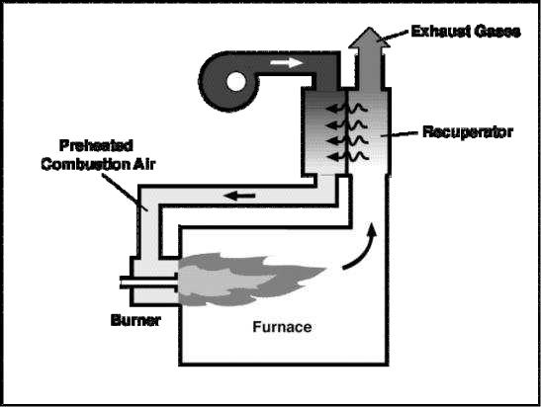
COOLED FLUE GASES OUT

COLD COMBUSTION AIR IN

HEATED COMBUSTION AIR TO BURNERS

HOT FLUE GASES IN

Metallic Radiation Recuperator
The metallic radiation recuperator is composed of two concentric metal tubes, as illustrated in Exhibit A-2. The inner tube carries hot exhaust gases, while the outer annular space transports combustion air from the atmosphere to the furnace burners. Heat transfer occurs as the hot gases cool down, transferring energy to the incoming combustion air, which then enters the combustion chamber with enhanced energy.
This recuperator is named for its reliance on radiative heat transfer. A significant portion of the heat transfer from the hot exhaust gases to the inner tube's surface occurs through radiation, primarily emitted by carbon dioxide and water vapor in the infrared spectrum. The effectiveness of radiative heat transfer depends on the gas temperature and the "path length" (the inner tube's diameter). This mechanism operates most efficiently at high temperatures, typically exceeding 1,400°F (760°C), making it suitable for high-temperature industrial processes.
While the cold air in the annular space is largely transparent to infrared radiation, it absorbs heat through convection as it flows along the inner tube's surface.
In the typical design, the exhaust gases and combustion air flow parallel to each other. Although a counter-flow configuration would simplify the design and improve heat transfer efficiency, parallel flow is often preferred. This choice allows the recuperator to serve an additional purpose: cooling the exhaust gas duct, thereby extending its operational lifespan.

Figure 4: Typical Radiation Recuperator
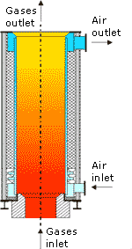
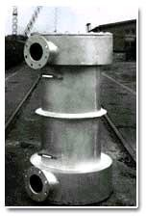

Hybrid Recuperator
Hybrid recuperators combine the strengths of both radiation and convective designs for enhanced heat transfer efficiency. They feature a high-temperature radiation section followed by a convective section. Although these systems are more expensive than simple metallic radiation recuperators, they are less bulky and offer improved heat transfer performance.

Ceramic Recuperator
Ceramic recuperators were developed to address the temperature limitations of metal recuperators, which are typically constrained to temperatures of 1,600°–1,800°F (870°–980°C) due to the material's technical and economic limitations. Early designs, constructed from tiles and furnace cement, often failed due to cracking and rapid deterioration caused by thermal cycling.
Modern ceramic recuperators use advanced materials like silicon carbide tubes, which are joined using flexible seals in the air headers to prevent leaks. These designs require precise sealing to prevent combustion air leakage at higher pressures. Recent advancements have resulted in various configurations with improved durability and heat recovery efficiency.

Limitations of External Recuperators
External recuperators are popular heat recovery devices but face several limitations:
- Temperature Constraints: Metallic recuperators have a temperature limit based on their construction materials. High-temperature alloys allow use with flue gases up to 1,600°F (870°C).
- High Costs: Recuperators designed for exhaust gases above 1,200°F (650°C) require expensive materials, with costs ranging from $10,000 to $15,000 per MM Btu recovered at 1,600°F (870°C).
- Contaminants: They cannot be used with gases containing particulates, corrosive elements, or condensable vapors.
- Maintenance: Ceramic recuperators require significant maintenance due to risks of air leaks and material damage during thermal cycling.

Self-Recuperative Burners
Self-recuperative burners represent a specialized class of recuperators where the recuperator is integrated directly into the burner system. This eliminates the need for separate hot air piping, providing a substantial cost advantage. Exhibit A-3 illustrates commonly used designs for direct-fired burners and radiant tube heating systems.

Figure 5: Self-Recuperative Burner Designs (Direct Fired and Radiant Tube Application)

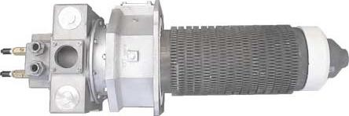
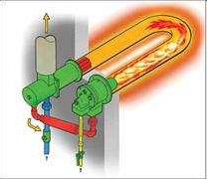

Self-Recuperative Burners
Self-recuperative burners are less effective in heat transfer compared to external recuperators, leading to limited fuel savings of 30%–60% compared to what is typically achieved with external recuperators.

Regenerators
Regenerators are commonly used in high-temperature applications, such as glass and steel melting furnaces, to recover heat from exhaust gases exceeding 2,500°F (1,370°C). These systems are constructed from high-temperature refractory bricks or specially designed ceramic components.
The performance of a regenerator is influenced by several factors:
- Size: Larger regenerators generally offer higher efficiency.
- Reversal Time: Shorter time spans between gas flow reversals improve thermal performance. Longer spans increase thermal storage requirements, raising costs and reducing the preheat temperature, which lowers fuel efficiency.
- Material Properties: The thickness, thermal conductivity, and heat storage capacity of the bricks play a critical role in efficiency.
Operational challenges can also impact regenerator performance:
- Fouling: Accumulation of dust and slag on surfaces reduces heat transfer efficiency as the system ages.
- Heat Losses: Heat can escape through the regenerator walls.
- Air Leaks: In-leaks during the gas cycle and out-leaks during the air cycle further diminish heat transfer efficiency.

Figure 6: Large Regenerative Heat Recovery System Used in Glass and Steel Industries
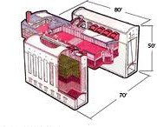

Regenerators
Regenerators deliver higher heat recovery efficiency compared to recuperators. However, they require significantly larger surface areas, making them bulkier and necessitating more frequent maintenance.

Regenerative Burners
Regenerative burners represent a specialized type of regenerator integrated with a pair of burners. These systems are smaller and incorporate compact ceramic pebbles or shapes as the heat storage medium. To achieve optimal performance, regenerative burners cycle more frequently than larger regenerators, typically every 20 seconds or less—nearly 50 times faster than traditional large-scale regenerators.
Despite their compact design, regenerative burners can achieve a heat recovery efficiency of 60%–80%, making them an effective solution for high-efficiency heat recovery in industrial applications.

Figure 7: Regenerative Burners for Medium to Small Furnaces
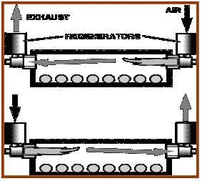

Regenerative Burners
These burners are designed for high-temperature industrial furnaces, such as aluminum melting, forge, or steel reheating furnaces. Although their initial cost is 2–3 times higher than that of a standard recuperator, regenerative burners can be equally cost-effective as traditional heat recovery systems. This is because they eliminate the additional expenses associated with hot air piping and preheated air burners.
However, these systems are not suitable for applications where flue gases contain significant quantities of particulates, condensable vapors, combustibles, or other contaminants.

Waste Heat Recovery Boilers
Waste heat recovery boilers are typically water tube boilers that utilize hot exhaust gases from gas turbines, incinerators, and similar sources. The exhaust gases pass over parallel water-filled tubes, vaporizing the water, which is then collected in a steam drum for heating or processing purposes.
To enhance heat transfer efficiency and minimize the boiler's footprint, finned water tubes are commonly used, increasing the effective heat transfer area on the gas side. Exhibit A-6 illustrates a waste heat boiler system designed to capture heat from gas turbine exhaust gases.

Figure 8: Waste Heat Boiler (HRSG) Application for Gas Turbine Exhaust Gases
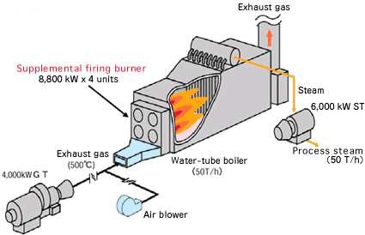

Waste Heat Boilers
Waste heat boilers, operating with exhaust gases in the range of 900°–1,100°F (480°–590°C), are commonly used in conjunction with supplementary fuel. The generated steam serves various applications such as process heating or power generation within the plant. These boilers typically achieve heat recovery efficiencies of 65%–70%. A similar configuration can also recover waste heat from furnaces or heaters.
The temperature of the waste heat directly impacts the pressure and production rate of the steam. The relationship between saturation pressure and temperature, as outlined in steam tables, governs this limitation. If the available waste heat is insufficient to generate the necessary process steam, auxiliary burners or after-burners can be integrated into the system to provide additional energy.
Before implementing waste heat boilers, consider the following key factors:
- Heat Load Requirements: These systems are economically viable only if the exhaust gas streams carry a significant heat load (>10 MM Btu/hr).
- Size Constraints: They are better suited for large-scale systems.
- Gas Cleanliness: Waste heat boilers are not suitable for exhaust gases containing substantial particulates or condensable vapors.
- Steam Demand: The system is impractical without a consistent need for steam in the plant.
- Variable Gas Flows: Fluctuating gas flow rates can necessitate auxiliary heat, which may lead to high operational costs and economic inefficiency.

Low- to Medium-Temperature Heat Recovery Equipment

Heat Wheels
Heat wheels are increasingly used in low- to medium-temperature waste heat recovery applications, typically up to 600°F (315°C). The system consists of a large, porous, rotating disk made of materials with high heat capacity. This wheel alternates between two adjacent ducts: one carrying hot gases and the other cold gases. Positioned so its axis lies parallel to the partition between the ducts, the wheel transfers heat from the hot gas stream to the cold gas stream as it rotates, enabling efficient thermal energy recovery.

Figure 9: Typical Heat Wheel Type Waste Heat Recovery Unit
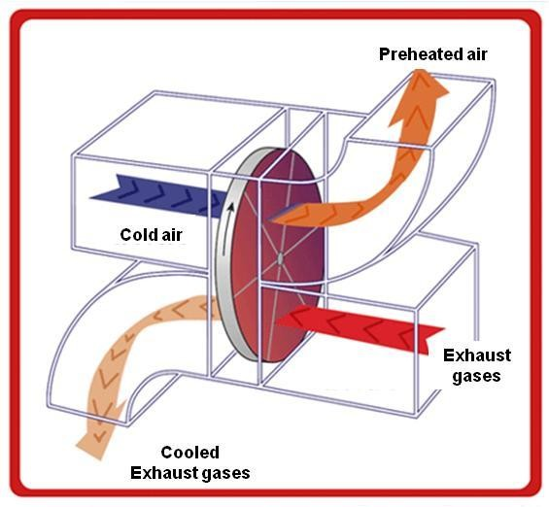

Heat Wheels
As the heat wheel disk rotates, it transfers sensible heat from the hot air stream to its surface, and then from the disk to the cold air stream. The system is highly efficient, with sensible heat transfer rates reaching up to 85%.
A variant of this system is the rotary regenerator, where the heat transfer matrix is a cylindrical component that rotates between waste gas and air streams. These systems, often referred to as energy recovery wheels, effectively transfer heat from exhaust gases to incoming air. They are particularly suited for applications involving large volumes of air with small temperature differentials.
Heat wheels require high-quality seals to maintain separation between the higher-pressure heated air and lower-pressure exhaust gases. Seal reliability and the potential for gas passage blockages are notable challenges. While heat wheels are commonly employed for preheating combustion air in boilers, their application in industrial furnaces is generally restricted to low-temperature ovens.

Heat Pipes
A heat pipe is an efficient thermal energy transfer system with no moving parts, requiring minimal maintenance. It is capable of transferring thermal energy at rates up to 100 times greater than copper, a well-known conductor.
As depicted in Exhibit A-8, a heat pipe consists of three key components:
- Sealed Container: This tube is vacuum-sealed to enable effective operation.
- Capillary Wick Structure: A wick is integrated into the interior surface of the container.
- Working Fluid: This fluid facilitates thermal energy transfer within the system.
When thermal energy is applied to the external surface of the pipe, the working fluid near the heated region evaporates instantly, absorbing the latent heat of vaporization. This area, known as the evaporator region, allows the vapor to travel to the opposite end of the pipe. At this end, thermal energy is extracted, causing the vapor to condense back into a liquid. This region is referred to as the condenser. The liquid then returns to the evaporator region via the capillary wick, completing the cycle. This process ensures highly efficient heat transfer with minimal energy loss.

Figure 10: Typical Heat Pipe Used for Waste Heat Recovery
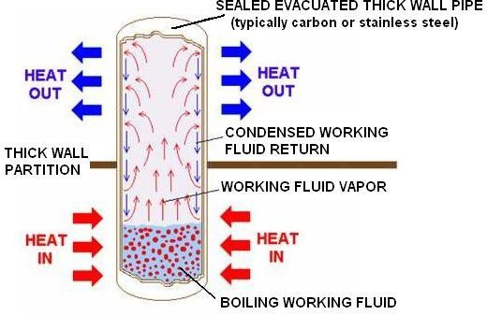

Heat Pipe Heat Exchanger (HPHE)
The heat pipe heat exchanger (HPHE) is a lightweight and compact heat recovery system, designed for minimal maintenance due to its lack of moving parts. It operates without requiring additional input power, cooling water, or lubrication systems. Additionally, it reduces fan horsepower requirements and enhances the overall thermal efficiency of the system. HPHEs are capable of achieving heat recovery efficiencies between 60% and 80%.

Common Industrial Applications of Heat Pipes
- Processing Space Heating:
HPHE transfers thermal energy from process exhaust to heat buildings. The preheated air can be mixed as needed, significantly reducing or even eliminating the need for additional heating equipment.
- Process-to-Process Energy Transfer:
HPHE recovers waste thermal energy from exhaust processes and transfers it to incoming process air, reducing overall energy consumption.
- Cooling:
In summer, HPHE pre-cools incoming makeup air for buildings, decreasing refrigeration requirements and improving cooling system efficiency.
- Heating:
During winter, the system reverses, preheating makeup air to reduce the need for additional heating.

Additional Industrial Uses
- Preheating boiler combustion air
- Recovering waste heat from furnaces
- Reheating fresh air for hot air dryers
- Waste heat recovery from catalytic deodorizing equipment
- Reusing furnace waste heat as a heat source for other ovens
- Cooling closed rooms using outside air
- Preheating boiler feed water with waste heat in heat pipe economizers
- Drying, curing, and baking ovens
- Waste steam reclamation
- Secondary recovery in brick kilns and reverberatory furnaces
- Heating, ventilating, and air-conditioning systems

Economizers
Economizers enhance boiler efficiency by preheating boiler feedwater or combustion air using flue gas heat.

Efficiency Gains
- Feedwater Preheating: For every 140°F (60°C) increase in feedwater temperature through an economizer, boiler fuel consumption is reduced by 1%.
- Combustion Air Preheating: A 392°F (200°C) increase in combustion air temperature through an air pre-heater also results in a 1% reduction in fuel usage.
- Flue Gas Heat Reduction: A 428°F (220°C) reduction in flue gas temperature correlates to a 1% fuel saving.
Economizers represent a straightforward and effective method for reducing fuel costs while improving the energy efficiency of boiler systems.

Figure 11: Feedwater Economizer – Typical Unit and Installation on a Boiler
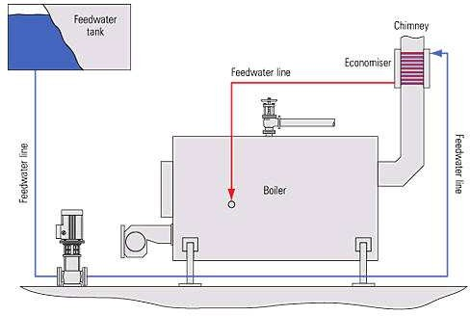
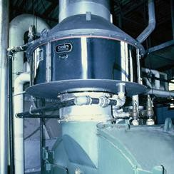

Shell and Tube Heat Exchangers
Shell and tube heat exchangers are ideal for applications where waste heat is transferred via a liquid or vapor to heat another liquid. Both paths must remain sealed to withstand the pressures of their respective fluids.

Design Features
- Shell and Tube Configuration:
The heat exchanger consists of a tube bundle enclosed within a shell, often with internal baffles. These baffles guide the fluid within the shell to flow across the tubes in multiple passes, enhancing heat transfer efficiency.
- Pressure Management:
Since the shell is inherently weaker than the tubes, the higher-pressure fluid is circulated through the tubes, while the lower-pressure fluid flows through the shell.

Vapor Applications
When vapor is used as the heat source, it typically condenses within the shell, releasing its latent heat to the liquid being heated. The vapor is almost always contained in the shell because condensation within the small-diameter tubes can create flow instabilities, making such configurations less efficient and less reliable.

Versatility
Shell and tube heat exchangers come in a wide range of standard sizes and can be constructed using various materials for both the tubes and the shell, accommodating diverse industrial requirements.
A typical shell and tube heat exchanger is depicted in Exhibit A-10.

Figure 12: Commonly Used Shell and Tube Type Heat Exchanger for Fluid Heating
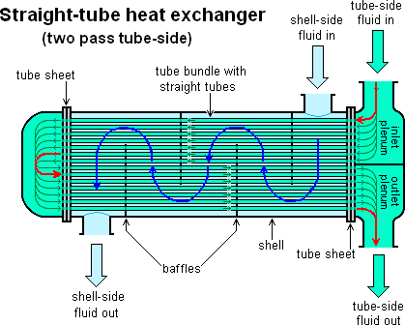

Applications of Shell and Tube Heat Exchangers
Shell and tube heat exchangers are commonly employed in the following areas:
- Refrigeration and Air Conditioning: For efficient heat transfer in cooling systems.
- Process Steam: Used in heating applications across various industries.
- Engines, Air Compressors, Bearings, and Lubricants: For temperature regulation and heat dissipation.
- Distillation Processes: Critical in separating mixtures based on boiling points.

Plate Heat Exchanger
When temperature differences are minimal, the cost of heat exchange surfaces becomes a critical consideration. Plate heat exchangers offer a cost-effective solution in such scenarios.

Design and Operation
- Structure:
Consists of a series of parallel plates, separated by gaskets, forming thin flow passages.
- Fluid Flow:
  - The hot fluid flows upward between every second plate, entering through a bottom port.
  - The cold fluid flows downward between the odd-numbered plates, entering through a top port.
- Heat Transfer:
The plates are corrugated to enhance heat transfer by increasing turbulence and surface area.
- Flow Arrangement:
When hot and cold fluids move in opposite directions, the configuration is called counter-current flow, maximizing efficiency.
A plate heat exchanger is illustrated in Exhibit A-11.

Figure 13: Commonly Used Plate Type Heat Exchanger for Fluid (Mostly Liquid) Heating
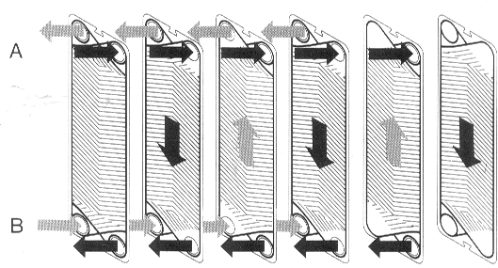

Applications of Plate Heat Exchangers
Plate heat exchangers are integral to several industrial processes, including:
- Milk Packaging: Used in the pasteurization stage to ensure product safety.
- Food Industry: Applied in evaporation plants for concentrating food products.
- Petroleum Refining: Employed for efficient heat recovery to enhance operational efficiency.
- Chemical Industry: Utilized for recovering heat in various chemical processing activities.

Run Around Coil Exchangers
Run around coil exchangers operate on a principle similar to heat pipe exchangers, transferring heat via an intermediate fluid known as the “heat transfer fluid.”

Key Features and Operation
- Design:
  - A closed-loop system with one coil in the hot fluid stream and another in the cold stream.
- Mechanism:
The heat transfer fluid absorbs thermal energy from the hot stream and releases it to the cold stream.
- Circulation:
A circulating pump maintains the flow of the heat transfer fluid throughout the loop.

Advantages
This system is especially beneficial when:
- Hot and cold fluids are physically distant from each other.
- Direct access to the fluid streams is challenging, necessitating an intermediary for heat transfer.

Figure 14: Heat Recovery for HVAC Application Using Recirculating Liquid
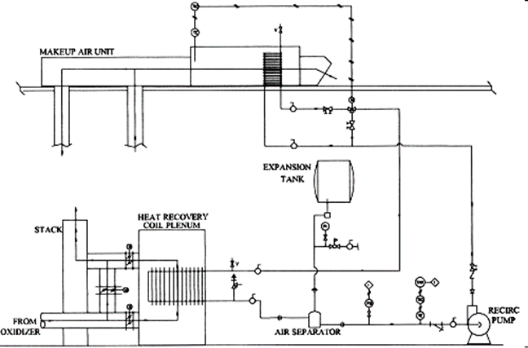

Typical Applications of Low-Temperature Waste Heat Recovery Systems
- Heat recovery from ventilation systems.
- Efficiency enhancement in air conditioning systems.
- Low-temperature heat recovery in various industrial processes.

Low-Temperature Waste Heat Recovery Systems

Features and Construction
Most low-temperature heat exchangers are constructed with copper tubing and aluminum fins, offering improved heat transfer characteristics. Key design elements include:
- Hairpin-shaped tubes: Increase fluid residence time for better heat exchange.
- Advanced Fin Designs: Enhance performance in finned tube heat exchangers.
- Coanda-Effect Louver Designs: Allow air to flow in a wave pattern, further improving efficiency.

Plastic Heat Exchangers

Advantages
Plastic heat exchangers provide a durable alternative to traditional metal heat exchangers, overcoming common issues like:
- Corrosion and oxidation.
- Microbiological attack.
- Galvanic action and material degradation.
Plastic tubing delivers consistent heat transfer rates, comparable to copper in most applications. Key benefits include:
- Vibration damping: Coils naturally absorb operational vibrations.
- Smooth surfaces: Resist material buildup and friction between tubing rows.
- Lightweight: Easier to install and maintain.

Limitations
Plastic heat exchangers are unsuitable for:
- High-pressure systems (>150 psi).
- High-temperature systems (>220°F or 105°C).
- Refrigerants or gaseous systems: Insufficient as vapor barriers.

Direct Contact Water Heaters
Direct contact water heaters utilize both sensible and latent heat from exhaust gases to heat water, with latent heat often accounting for over 90% of the total heat recovery.

Operation
- Cold Water Inlet: Water enters through a top nozzle and sprays over heat transfer media.
- Hot Exhaust Gas: Flows from the base of the system in a counterflow direction.
- Preheating: Heat transfer occurs as water droplets pass through stainless steel media, absorbing heat from the rising flue gas.
These systems are efficient for recovering heat from boiler exhaust gases, providing significant energy savings in industrial processes.

Figure 15: Direct Contact Water Heater Used for Latent Heat Recovery from Flue Gases
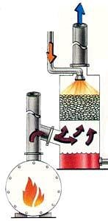
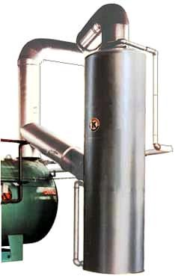

Direct Contact Water Heaters
Final Heating Process
Water is finally heated in the direct contact chamber. From there, it moves to a hot water storage system via a transfer pump or gravity, and subsequently to the direct contact water heater.
Water Properties and Applications
The hot water produced contains carbonic acid, formed due to dissolved flue gas CO₂. As a result, this water is suitable only for selective applications and is not recommended for recycling. In some cases, a secondary heat exchanger made from appropriate materials can be employed to recover heat from this acidic water.
Efficiency and Challenges
Direct contact water heaters recover up to 90% of flue gas heat content, depending on factors such as flue gas temperature and the inlet water temperature. Higher outlet gas temperatures significantly reduce heat recovery efficiency. Key barriers to usage include:
- Limited water temperature rise.
- Acidic nature of heated water.
- Potential for plugging of media in the unit.
Industrial Applications
These heaters are widely used in:
- Food industry
- Cement industry
- Automotive industry
- Laundry and textile industry

Heat Pumps
Principles and Operation
Heat pumps reverse the natural flow of heat, upgrading low-grade waste heat for useful applications. Operating on the vapor compression cycle, they utilize a closed loop of circulating fluid (refrigerant) for efficient energy transfer. The process involves:
- Evaporation: Heat from the source is absorbed to boil the refrigerant.
- Compression: The refrigerant vapor is compressed, raising its pressure and temperature.
- Condensation: Heat is released to a heat sink as the refrigerant condenses.
- Expansion: The refrigerant is throttled back to its initial state to repeat the cycle.
Applications
Heat pumps are effective for space heating and cooling, with potential uses in:
- Plastics factories (cooling injection-molding machines and heating offices).
- Product drying and maintaining storage conditions.
- Drying compressed air.

Thermo-Compressor
Purpose
A thermo-compressor reuses low-pressure steam by compressing it into medium-pressure steam. This process leverages the latent heat of steam for improved waste heat recovery.
Operation
- High-pressure steam is accelerated through a nozzle, creating a high-velocity jet.
- The jet entrains low-pressure steam through momentum transfer.
- The combined steam is recompressed using a venturi.
Applications
Thermo-compressors are commonly used in evaporators, where boiling steam is recompressed for reuse as heating steam.

Thermally Activated Technologies (TAT)
Overview
TAT systems utilize waste heat for multiple purposes, including heating, cooling, humidity control, and power generation. These technologies include:
- Absorption chillers
- Desiccant systems for humidity control
- Organic Rankine Cycle systems for power generation
Combined Heat and Power (CHP) systems can also be categorized under TAT when they utilize waste heat for power generation.

Absorption Chillers
Functionality
Absorption chillers transfer heat via an absorbent fluid and refrigerant, operating in either:
- Ammonia–Water Systems
- Lithium Bromide–Water Systems
Ammonia–Water Systems
- Utilized in both small refrigerators and large-scale heat recovery setups.
- Efficient but requires external placement due to ammonia’s toxicity.
Lithium Bromide Systems
- Widely used for industrial applications due to lower toxicity.
- Uses low-pressure steam as an energy source.
Key Processes
- Refrigerant absorbs heat from the source, evaporates, and releases heat in the condenser.
- Absorber mixes refrigerant vapor with a strong absorbent solution, repeating the cycle.
Applications
Absorption chillers are commonly used in industries requiring cooling systems, including factories and power plants.

Summary of Applications

Direct Contact Water Heaters
- Cleaning water.
- Process water in food, cement, automotive, and textile industries.

Heat Pumps
- Space heating and cooling.
- Plastics industry and product drying.

Thermo-Compressors
- Steam compression in evaporators.

Absorption Chillers
- Cooling systems in industrial and power generation setups.

Figure 16: Simplified Absorption Cycle Using Heat
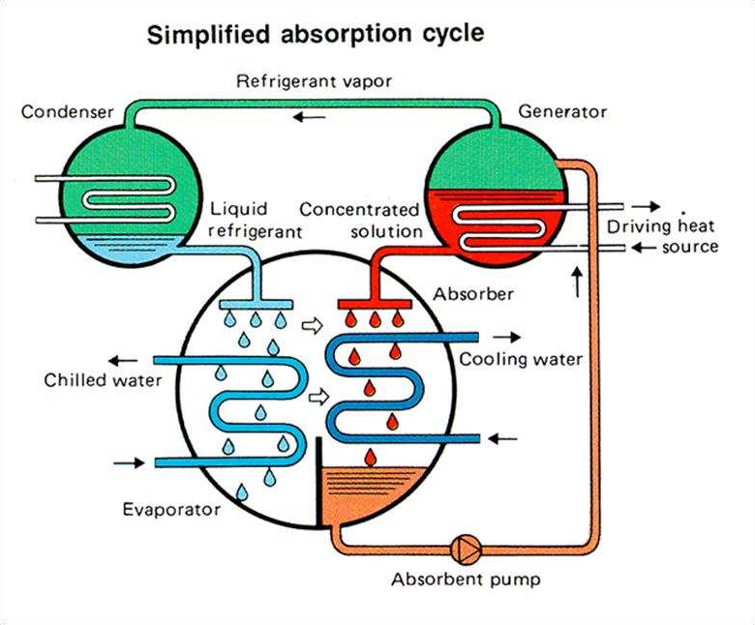
Coefficient of Performance (COP)
The efficiency of cooling systems, including chillers, is measured using the coefficient of performance (COP). It is defined as the ratio of cooling output to the required heat input.
- Single-effect absorption units without extensive heat recovery exchangers typically have a COP of 0.45–0.7.
- Electrically operated systems, by comparison, achieve a COP of 4.5–6.0.
Despite their lower COP, absorption units that utilize waste heat have significantly lower operating costs compared to electrical systems.
Cost Considerations
Total costs include:
- Installation costs.
- Auxiliary equipment expenses (e.g., cooling towers, water pumps, and piping).
Typically, absorption systems are about 50% more expensive than their electrical counterparts. Additionally, auxiliary system costs account for approximately 33% of the total system cost.

Power Generation Systems
A subset of heat recovery systems leverages waste heat for electric power generation. These systems are increasingly popular in industrial applications. Key options include:
- Conventional plants (steam boiler, steam turbine, and generator).
- Organic Rankine Cycle (ORC) systems.
- Ammonia–water systems (e.g., Kalina and Neogen systems).
- Supercritical carbon dioxide systems.
- Thermo-electric generators (TEG).

Conventional Plants (Steam-Based Systems)
Operation and Efficiency
Steam-based systems are suited for high-temperature waste heat sources (typically above 600°F (315°C)). These systems use clean exhaust gases to produce high-pressure steam, which drives a turbine connected to a generator. Efficiency rates typically range between 25%–30%.
- These systems are most effective in large-scale applications, such as steel reheating furnaces, cement kilns, and lime kilns.
Limitations
Several challenges limit the use of conventional systems:
- Require clean, contamination-free waste heat sources, free from particulates and corrosive vapors.
- Depend on continuous or predictable waste heat flow.
- Operate best at moderate to high temperatures (>300°F (150°C), preferably >600°F (315°C)).
- Low conversion efficiency of waste heat to electricity.
- Supplementary fuel usage can negatively impact economic viability unless power costs justify it.
Economic Considerations
Conventional systems are generally not suitable for:
- Situations where heat can be reused directly within the process.
- Instances where alternative heat recovery methods (e.g., cascading or hot water recovery) are feasible.
Adoption depends on electricity costs and the potential to reduce peak demand charges. Supplementary fuel use should be minimized to enhance system economics.

Summary of Power Generation Technologies
- Organic Rankine Cycle (ORC): Suitable for low-temperature heat sources.
- Ammonia–Water Systems: Efficient but require careful handling.
- Supercritical Carbon Dioxide Systems: Emerging technology with high potential.
- Thermo-Electric Generators (TEG): Compact and ideal for specific applications.
Each technology offers unique advantages and constraints, making them viable options depending on the industrial application and waste heat conditions.

Figure 17: Schematic for Electrical Power Generation System Components
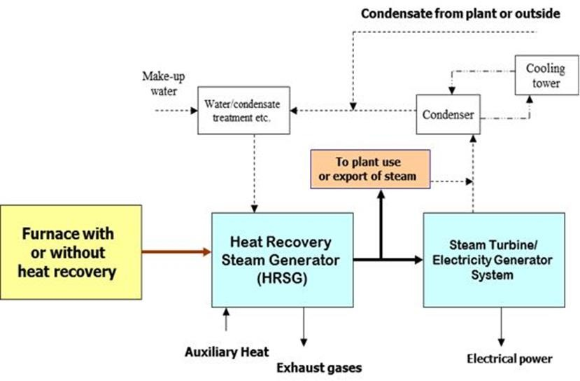

The Organic Rankine Cycle (ORC) refers to a group of systems that utilize waste heat to generate electrical power. The differences among these systems primarily arise from the choice of working fluid and the types of critical components employed. Exhibit A-16 illustrates the schematic of a standard ORC system.

Figure 18: Organic Rankine Cycle (ORC) System Components
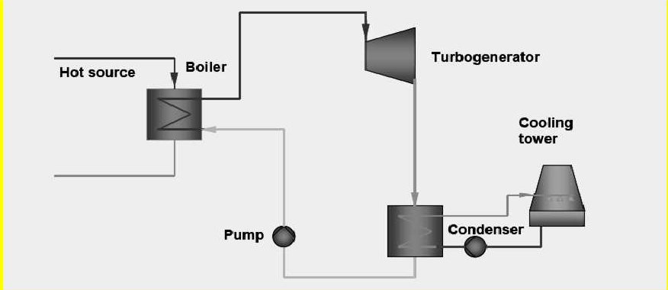

A heat source, such as hot water, steam, or in some cases, flue gases, is utilized to heat and evaporate a high-pressure working fluid. Common working fluids include refrigerants like R124, R134a, or R245fa, as well as light hydrocarbons such as iso-butane, n-butane, iso-pentane, and n-pentane. The system employs a turbo generator to expand the vapor's pressure, converting it into mechanical work, which is then transformed into electricity via an attached electrical generator. The vapor is subsequently cooled and condensed in a condenser, while a pump increases the pressure of the resulting liquid to restart the cycle. Cooling water, typically maintained between 60°–90°F (15°–32°C), is supplied to the condenser, and the heated water is then cooled in a cooling tower.
The waste heat source must provide a minimum temperature of approximately 300°F (150°C) to the evaporator. Variations in Organic Rankine Cycle (ORC) systems are offered by various suppliers, but the system's overall performance remains within a narrow range due to thermodynamic constraints.
The term "efficiency" in ORC systems reflects the percentage of energy from the heating medium converted into electricity. Efficiency ranges from 8% to 15%, depending on the heat source temperature, which typically spans 300°–800°F (150°–430°C). System costs range between $2,500 and $3,500 per kW of design capacity. As shown in Exhibit A-17, a significant portion of these costs is attributed to heat exchangers, highlighting the importance of developing compact and cost-effective heat exchanger designs to reduce both costs and system footprints.
Historically, most ORC applications have been in geothermal energy and non-industrial sectors. However, ORC systems are now being explored and implemented in industrial applications, marking a shift in their usage potential.

Figure 19: Organic Rankine Cycle (ORC) System Components and Cost Distribution
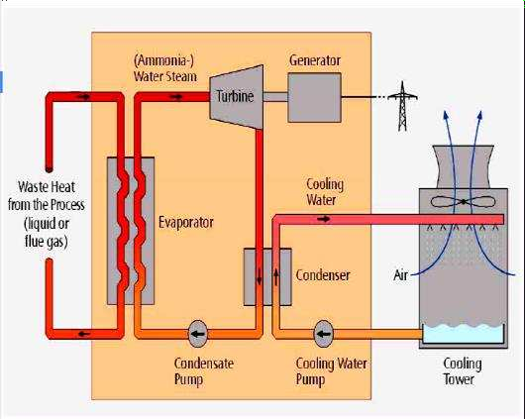
Water/condensate
Other cost
25%
Heat excahngers
30%
Pow er distribution
15%
Turbine - Generator
15%
Cooling w ater system
15%

Ammonia–Water System: The Kalina Cycle
The Kalina cycle utilizes a 70% ammonia–30% water mixture as its working fluid, offering substantial efficiency improvements over the traditional Rankine cycle. Its system design is similar to the Organic Rankine Cycle (ORC) but incorporates additional heat exchangers to maximize heat recovery and enhance overall performance. The Kalina cycle operates effectively across a wide temperature range, from 250°F (120°C) to 1,000°F (540°C), with suitable heat exchanger configurations.
The system achieves higher operating efficiency than ORC systems, approximately 15% at waste heat temperatures around 300°F (150°C), with further improvements at higher heat source temperatures. This efficiency gain stems from the unique thermodynamic properties of the ammonia–water mixture, which boils over a range of temperatures rather than at a single point. This characteristic allows for greater energy recovery from the gas stream. Similarly, condensation occurs across a temperature range, enabling additional heat recovery compared to the Rankine cycle, where ambient conditions restrict condenser back pressure and, consequently, power output.
The total cost of the Kalina cycle system ranges between $2,000 and $3,000 per kW of capacity, higher than that of ORC systems. A significant portion of these costs, both capital and maintenance, is attributed to the heat exchangers. To date, most Kalina cycle applications have been in geothermal energy and non-heavy industrial sectors, where its efficiency and adaptability can be effectively leveraged.

Figure 20: Kalina Cycle System Components
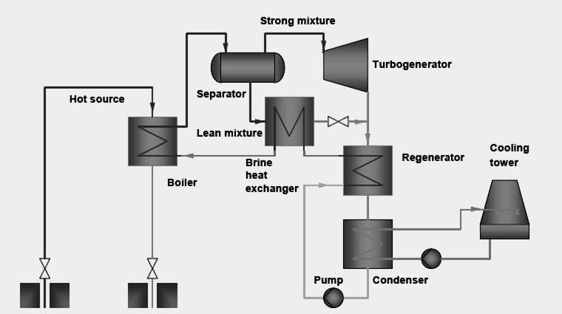

Supercritical Carbon Dioxide Cycle
The use of supercritical carbon dioxide (sCO₂) for low-temperature power generation is a relatively recent innovation. This technology is further detailed in the emerging technology section of this appendix.

Thermo-Electric Power Generation (TEG)
Thermoelectric (TE) technologies are promising candidates for the direct conversion of waste heat into electricity. TE materials, which are semiconductor solids, generate an electric current when subjected to a temperature difference across their junctions—a principle similar to that of thermocouples. By applying waste heat to one side of a TE material and maintaining a cooler or ambient temperature on the other, direct current electricity is produced.
The efficiency of waste heat conversion to electricity depends on the material properties and the temperature difference between the hot and cold sides. Current TE systems are designed to operate within a temperature range of 400°–900°F (200°–480°C), achieving typical efficiencies of 5%–7%. With advancements in innovative materials, such as nanomaterials, efficiencies could potentially reach 15%.
As illustrated in Exhibit A-19, a TE power generation system comprises four main components:
- TE Module: An array of several or hundreds of TE material junctions.
- Hot-Side Heat Exchanger: Transfers heat from the waste heat source to the TE module.
- Cold-Side Heat Exchanger: Maintains a lower temperature on the opposing side of the TE module.
- Power Electronics Module: Regulates the output to provide the desired voltage and current.
This approach continues to gain attention as material science progresses, offering improved efficiency and expanded applications for waste heat recovery systems.

Figure 21: Thermo-Electric Generator (TEG) System Components
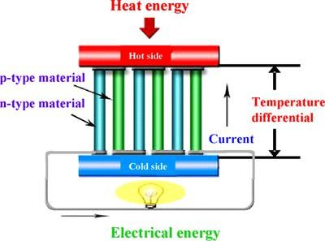

The design and operation of each component in a Thermo-Electric Generator (TEG) system play a crucial role in achieving the expected performance for industrial waste energy recovery.
Currently, the cost of TEG units exceeds $5,000 per kW of power production, making them a costly option. Industrial applications for TEG systems remain in the early development stages and are not yet proven for widespread use. Significant research and development, along with pilot demonstrations, will be required before TEG technology becomes viable for converting industrial waste heat into power.
For waste heat temperatures above 800°F (425°C), conventional steam turbine-generator systems are the most attractive and proven option for clean, contamination-free waste heat. At lower waste heat temperatures, Organic Rankine Cycle (ORC), ammonia–water systems, and CO₂-based systems are available; however, none have a long-standing, proven track record in industrial applications to ensure economically viable power generation.
For waste heat temperatures below 400°F (200°C), it is challenging to justify waste heat-to-power projects, particularly if the heat supply is inconsistent or requires auxiliary energy inputs.
Thermo-electric systems, designed for operation in the 400°–900°F (200°–480°C) range, are still in early development. With reported efficiencies below 5% and costs exceeding $5,000 per kW, their use is not currently economically feasible except in niche applications. Further advancements in research, material science, and pilot demonstrations are essential before this technology can be broadly applied for waste heat-to-power conversion.

Table 16: Comparison of Low Temperature Electric Power Generation Systems

Comparison | Steam Rankine | Organic Rankine  (ORC) | Ammonia (NH3)– Water | Supercritical CO2 Power Cycle
Source Temperature Range °F (°C) | 800°F+ (430°C+) | 200 to 500°F  (90 to 260°C) | 200 to 800°F  (90 to 430°C) | 400 to 1,200°F  (200 to 650°C)
Working Fluid | Treated water | HCFCs or hydrocarbons | Ammonia-water mixture | Carbon dioxide
Working Fluid Attributes | Requires treatment to reduce corrosion and mineral  deposition | Limited temperature range, flammability, thermally unstable at  higher temperature | Limited temperature range, corrosive, ammonia leaks | Corrosive, non-toxic, non-flammable, thermally stable
Conversion  Efficiency | 20%+ | 8 to 12% | 8 to 15% | 13 to 17%
Reported Cost  ($/kw) | $600+ | $2,500+ | $2,500+ | $2,000+
Note: This is a fast-changing field. The efficiency values are highly dependent on the source temperature. Cost could vary significantly with size, supplier and incentives from several sources.

Emerging Waste Heat Recovery Technologies
New developments are continuously being explored to enhance the performance of existing systems and advance waste heat recovery technologies. While many technologies are already in use, suppliers are making incremental improvements to expand applications and optimize performance in their current markets. However, the emergence of entirely new technologies remains limited.
Detailed information about these advancements is often proprietary, making it challenging to gain comprehensive insights. The following section provides an overview of key emerging technologies and their potential benefits, with information sourced from the Gas Technology Institute (GTI).

Advanced Heat Transfer Enhancement
This innovation focuses on improving the convection heat transfer coefficient in heat exchangers, particularly for low- to medium-temperature applications where convection, rather than radiation, dominates heat transfer performance. The technology aims to boost heat exchanger efficiency while managing the associated increase in energy consumption for blowers and compressors.
A key feature of this technology is the use of dimpled tubes in place of traditional finned tubes. As illustrated in Exhibit A-21, dimpled tube configurations can achieve heat transfer rates 2–3 times higher than bare tubes, with an associated pressure drop increase of approximately 50%. The extent of these improvements depends on the dimple size.

Benefits of Advanced Heat Transfer Technology
- Enhanced Efficiency: Significant improvement in heat transfer performance.
- Cost Reduction: Overall system cost is typically reduced by 20%–30%.
- Improved Maintenance: Lower risk of surface deposits that degrade performance, resulting in reduced maintenance requirements.
- Durability: Longer life span due to easier and less frequent tube replacements.
This innovation offers a cost-effective solution for applications like economizers, enabling higher performance and operational reliability while minimizing expenses.

Figure 22: Convection Heat Transfer Enhancement by Using Dimpled Tubes
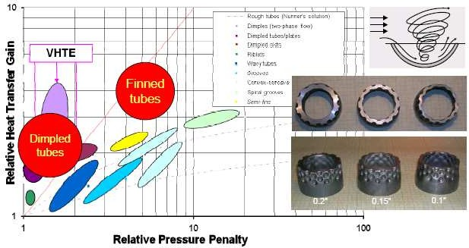

At present, the adoption of this technology remains limited due to the unavailability of dimpled tubes and reluctance among manufacturers to invest in their production. The Gas Technology Institute (GTI) is actively collaborating with heat transfer equipment suppliers to promote awareness of the technology and its potential advantages.

Thermochemical Recuperation of Fuel Gas
Thermochemical recuperation is a promising technology designed for medium- and high-temperature waste heat streams, particularly in natural gas-fired burners and similar equipment utilizing gaseous flues. This process leverages waste heat to drive an exothermic natural gas reforming reaction, producing carbon monoxide (CO) and hydrogen (H₂), thereby enhancing the heating value of natural gas. The reforming reaction can utilize air, oxygen, or steam as a reactant.
According to GTI, this technology can lead to an overall energy reduction of 6%–10% in gas-fired internal combustion (IC) engines, with similar efficiency gains achievable in other fired equipment.

Energy Savings and Performance
A set of Sankey diagrams for a gas-fired system (shown in Exhibit A-22) illustrates the energy-saving potential:
- Base Value: Energy usage starts at 100.
- Conventional Recuperator: Preheating combustion air reduces energy use to 72.
- Thermochemical Recuperation: Incorporating this technology further lowers energy use to 54, an additional 18% reduction.
This technology has been successfully demonstrated for IC engine applications. GTI reports that for most high-temperature, continuous-use applications, the system offers a payback period of less than one year, making it a highly attractive option for industrial energy efficiency improvements.

Figure 23: Heat Balance (Sankey Diagrams) Showing Energy Savings with Use of Thermochemical Recuperative (TCR) System
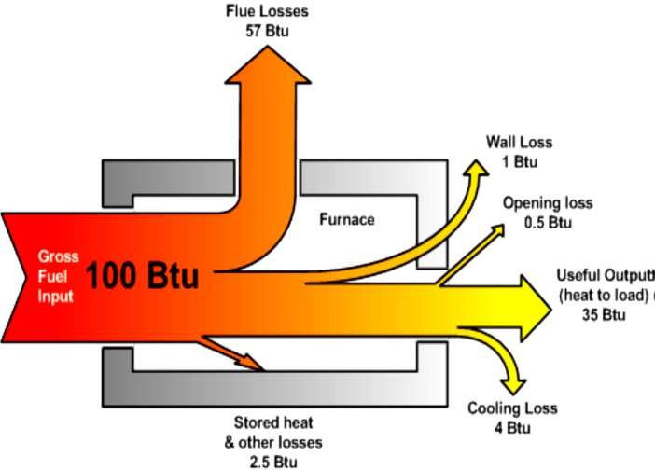
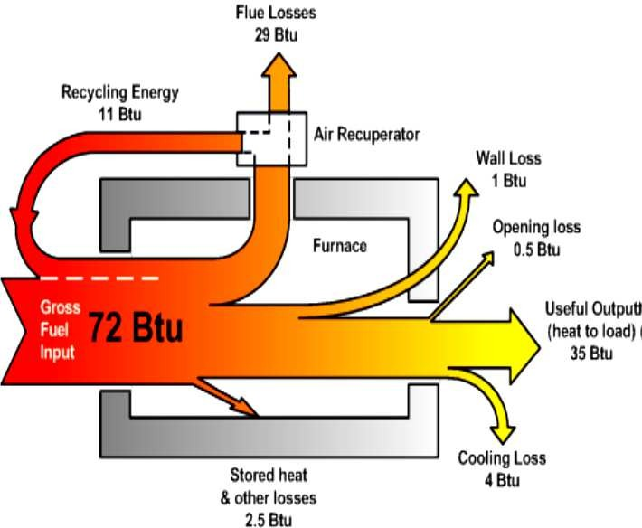

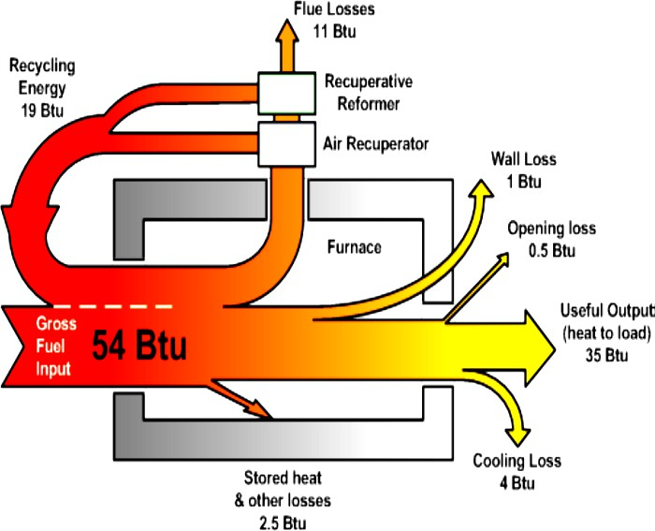

Water Vapor Condensation in Exhaust
Recovering the latent heat of water vapor from combustion gases with high moisture content can enhance heat recovery efficiency by at least 10%. To achieve this, the Gas Technology Institute (GTI) has developed an Advanced Heat Recovery System (AHRS) incorporating the Transport Membrane Condenser (TMC).
The TMC consists of bundles of porous ceramic membrane tubes. As illustrated in Exhibit A-23, combustion products from boilers and other heating systems pass through the TMC, where both latent and sensible heat, along with water vapor, are recovered. This process involves dehumidifying the flue gas and capturing condensed water vapor.

How the System Works
- Gas Flow: Flue gases flow through the TMC, where heat and moisture are extracted.
- Heat Exchange: Cold water or boiler feedwater flows inside the tubes, drawing the heat-laden moist air into the membrane structure.
- Condensation Process: Water vapor condenses on the inner separation membrane layer, aided by a slight vacuum used as a motive force.
- Separation: The membrane allows only water vapor to condense and be recovered, while other flue gas components, with larger molecular sizes, pass through.

Benefits
- Pure Water Recovery: The system captures pure water, reducing dependency on fresh water supplies.
- Enhanced Heat Recovery: The latent heat of the condensed water vapor is transferred to the boiler feedwater, significantly improving energy efficiency.
- Reduced Water Requirements: By recycling condensed water and its associated heat, the demand for fresh water decreases proportionately.
This innovative approach not only improves energy efficiency but also supports sustainable water management practices, making it a valuable addition to industrial heat recovery systems.

Figure 24: Transport Membrane Condenser (TMC) System Components
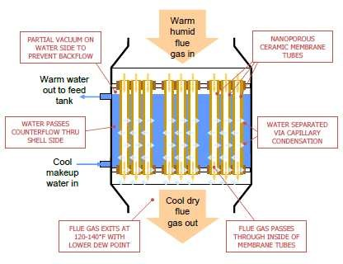

Advanced Heat Recovery System (AHRS)
The implementation of the Advanced Heat Recovery System (AHRS) in boiler applications can achieve up to 95% fuel-to-steam efficiency. Key benefits include:
- Fuel Savings: A reduction of 15%–20% in fuel consumption.
- Water Recovery: Recovery of 30%–50% of water from flue gases.
- Emission Reduction: A decrease of 15%–20% in greenhouse gas emissions.
The AHRS has demonstrated long-term operational reliability, with over 15,000 hours of use at a rubber plant in Alabama and successful deployments at food processing plants, pharmaceutical facilities, and a military base.

Super Boiler
The Super Boiler, though not strictly a waste heat recovery system, exemplifies the integration of waste heat reduction and recovery technologies to enhance the performance of industrial boilers.

Overview
The Super Boiler Program, initiated by the U.S. Department of Energy in partnership with industrial collaborators, aims to revolutionize energy efficiency in high-pressure steam boilers. This innovative system integrates multiple technologies into a single, compact unit.

Key Features
- Footprint Optimization: A compact design with reduced space requirements.
- Advanced Heat Recovery: Incorporates an AHRS featuring the Transport Membrane Condenser (TMC).
- Ultra-Low NOx Combustion: Minimizes nitrogen oxide emissions while maintaining high turndown ratios.
- State-of-the-Art Controls: Offers precise control for optimal performance.
- Enhanced Heat Transfer: Uses AluFer tubes to extend heat transfer surfaces without refractory materials.

System Components
The Super Boiler integrates the following components into a unified system:
- Boiler: A two-pass, high-pressure steam fire tube boiler.
- Economizers:
  - High-Temperature Economizer: Preheats feedwater after the deaerator unit.
  - Low-Temperature Economizer: Preheats feedwater before the deaerator unit.
- Transport Membrane Condenser (TMC): Recovers latent heat by condensing water vapor from exhaust gases.
- Humidifier Air Heater: Preheats combustion air using recovered heat.
This integrated system offers significant advancements in energy efficiency, emissions reduction, and water recovery, making it a transformative solution for industrial steam applications.

Figure 25: Super Boiler System Components
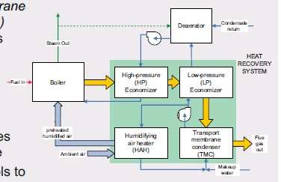

Super Boiler Design
The Super Boiler integrates advanced technologies to achieve significant performance improvements:
- Compact Footprint: A 50% reduction in boiler size.
- Fuel Efficiency: A 15%–20% reduction in fuel consumption.
- Water Recovery: Recovers 30%–50% of water from flue gases.
- Emission Reduction: Decreases greenhouse gas emissions by 15%–20%, with ultra-low NOx levels (<9 ppm).
However, challenges remain with the technology:
- Cost and Payback: The initial investment and return on investment require careful evaluation.
- Material Fragility: The ceramic membrane (TMC) tubes are prone to damage, impacting durability.

Supercritical CO₂-Based Power Generation Technology
Innovative systems utilizing supercritical CO₂ (ScCO₂) as the working fluid are under development for waste heat-to-power applications. These systems leverage ScCO₂'s unique thermodynamic properties for efficient energy recovery and conversion. Below is an overview of one such system.

EchoGen System – Thermal Engine
The EchoGen Thermal Engine employs liquid CO₂ as the working fluid, operating through the following process:
- Pumping: Liquid CO₂ is pressurized to supercritical levels.
- Preheating: The pressurized CO₂ flows through a recuperator for preheating.
- Heat Absorption: Preheated CO₂ enters a heat exchanger, where it absorbs heat and vaporizes at supercritical pressure.
  - Heat Source: Waste heat from sources ranging between 400°F and 1,200°F (200°C to 650°C).
- Expansion: High-energy ScCO₂ expands in a turbo-alternator, generating high-frequency electrical power.
- Condensation: Low-pressure ScCO₂ vapors are condensed back into a liquid state using cold air or water in a condenser.
- Power Conditioning: Advanced power electronics convert and condition the generated power to meet customer specifications.
This approach demonstrates potential for efficient power generation from low-temperature waste heat, offering versatility for various industrial applications. However, further advancements in technology, scalability, and cost efficiency are essential for widespread adoption.
.

Figure 26: Electrical Power Generation System that Uses Supercritical Carbon Dioxide – Echogen System
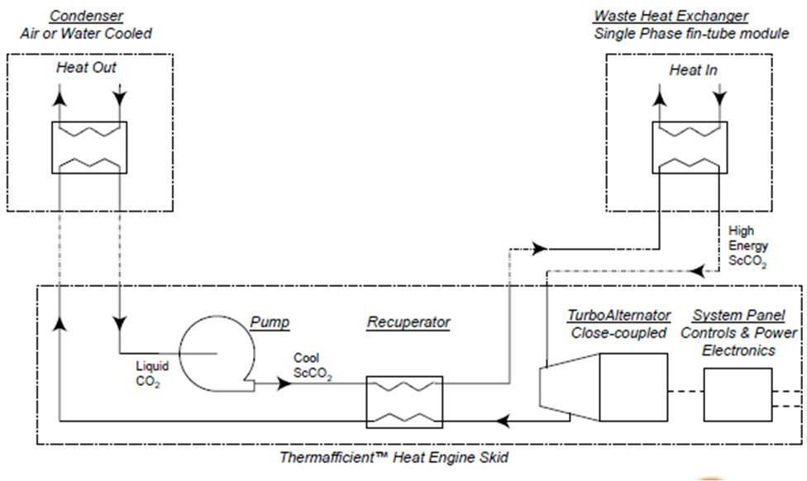

The developer reports an efficiency of 13.6%–17.5%, calculated based on the heat supplied to the system and the electrical power generated.

Key Advantages of the System
- Elimination of Temperature Pinch Limits:
  - Above critical pressure, fluids lose distinct liquid and vapor phases, removing the “pinch” temperature limit that steam encounters in waste heat exchangers.
- Thermal Stability:
  - Unlike ORC systems, where HCFC and HFC-based working fluids thermally degrade at ~500°F (260°C), CO₂ remains stable, eliminating the need for a bypass stack.
  - This stability enhances operational reliability and efficiency.
- Safety and Direct Heat Transfer:
  - CO₂ is non-flammable, allowing for direct heat transfer from gases to the working fluid.
  - In contrast, ORC systems rely on flammable, hydrocarbon-based fluids, necessitating an intermediate heat transfer fluid loop for safety, which increases costs and system size.
  - Eliminating intermediate heat exchangers reduces both the cost and footprint of the system.

System Performance and Development
- Laboratory-Scale System: A 5 kW prototype was built and successfully demonstrated.
- Pilot-Scale System: Following the initial tests, a 15 kW pilot unit was constructed and tested in a laboratory setting.
- Demonstration System: The company partnered with a utility provider to develop a 250 kW demonstration unit.
  - This skid-mounted system, operational since 2010, was constructed as a full-scale test model for further validation.
The skid-mounted 250 kW unit's design and dimensions are depicted in Exhibit A-26, showcasing its compact and efficient layout tailored for industrial applications.

Figure 27: 250 kW Demonstration Unit – Echogen System
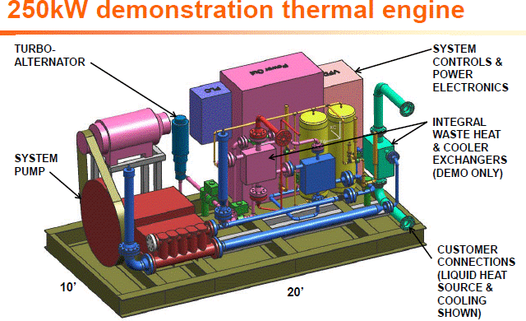

The projected cost for the system, including standard installation, is approximately $2,100 per kW, making it 15%–25% less expensive than comparable ORC systems.

Natural Energy Engine (NEE) – Deluge Inc.
This innovative waste heat recovery system utilizes reciprocating cylinders and CO₂ as the working fluid to transform thermal energy into mechanical work.
- Process Overview:
  - Hot water, heated via waste heat in a separate heat exchanger, transfers its thermal energy to liquefied CO₂, the working fluid.
  - The CO₂, with its high coefficient of expansion, expands to drive a piston inside the engine cylinder.
  - The piston’s motion is converted into mechanical energy to operate a hydraulic motor or perform other tasks.
  - Cooling water enters the heat exchanger, contracting the CO₂ and resetting the piston for the next cycle.
- Efficiency:
  - Mechanical work efficiency: ~23%
  - Electrical generation efficiency: ~20%

Key Advantages
- Simplified Design:
  - No high-speed turbo machines or expanders are required.
  - Fewer moving parts reduce wear and maintenance.
- Efficiency and Noise Reduction:
  - Minimal heat losses.
  - Fully hydraulic transmission ensures smooth operation.
  - Operates with low noise levels.
- Operational Flexibility:
  - Utilizes heat sources at or above 200°F (95°C).
  - Operates efficiently with a temperature differential of 100°F (37°C) (e.g., from 80°F cold water to 180°F heated water).

Applications and Current Testing
This system has been successfully employed in oil fields to power reciprocating engines. Currently, a 250 kW prototype unit is under testing to evaluate its electrical performance, utilizing geothermal energy as a heat source.
This technology holds significant promise for cost-effective and sustainable energy recovery from low-temperature waste heat.

Figure 28: Natural Energy Engine – a Liquid Carbon Dioxide (CO₂) Based Power Generation System
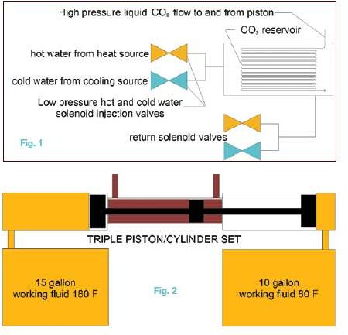

The estimated cost of the unit is approximately $2,000 per kW, though this may vary significantly based on the specific application and location.

Challenges
- Unproven Design:
  - The technology has yet to demonstrate consistent reliability in diverse real-world scenarios.
- Maintenance Concerns:
  - Maintenance of the cylinders and pistons, particularly the seals, presents a potential operational challenge.
- CO₂ Replacement Costs:
  - The expense associated with replenishing CO₂ adds to the overall operational cost.
Field testing of the pilot unit is expected to provide insights and solutions to these challenges, helping to establish the technology’s viability for broader applications.

References

- BCS, Incorporated, Waste Heat Recovery: Technology and Opportunities in U. S. Industry, prepared for the U.S. Department of Energy, Industrial Technologies Program, March 2008.
- Energetics Incorporated and E3M, Incorporated, Energy Use, Loss and Opportunities Analysis: U.S. Manufacturing & Mining, prepared for the U.S. Department of Energy, Industrial Technologies Program, December 2004.
- Lawrence Berkeley National Laboratory, Energy Efficiency Improvement and Cost Saving Opportunities For Petroleum Refineries: An ENERGY STAR® Guide for Energy and Plant Managers, prepared for the U.S. Environmental Protection Agency, February 2005.
- Lawrence Berkeley National Laboratory and American Council for an Energy-Efficient Economy,
Emerging Energy-Efficient Industrial Technologies, October 2000.
- McKinsey & Company, Unlocking Energy Efficiency in the U.S. Economy, July 2009.
- Pacific Northwest National Laboratory, Opportunity Analysis for Recovering Energy from Industrial Waste Heat and Emissions, prepared for the U.S. Department of Energy, April 2006.
- Pacific Northwest National Laboratory and BCS, Incorporated, Engineering Scoping Study of Thermoelectric Generator (TEG) Systems for Industrial Waste Heat Recovery, prepared for the U.S. Department of Energy, Industrial Technologies Program, November 2006.
- Martin Fleer: “Heat Recovery from the Exhaust Gas of Aluminum Reduction Cells” REYST” report
07-2010, July 2010

